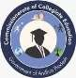
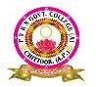
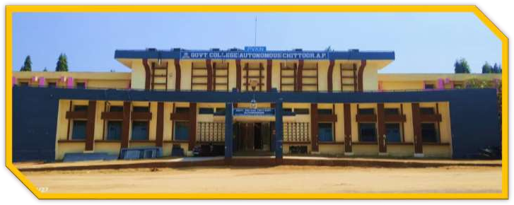



MOTTO: Learn Today – Lead Tomorrow


AUGUST2026


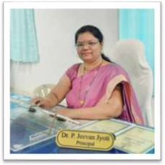
Education is an essential ornament that can lead to our success. Life brings to us different challenges and education helps us in dealing with those challenges in a better way. Education raises the individual to a higher level of awareness and understanding. It provides a person with a unique standard in life and also a feeling of well-being which differentiates human beings from other creatures.

Imparting Value Education is the prime objective of PVKN Govt College (A), Chittoor. The college has the potential to face the challenges of varied requirements of the students. This prestigious institution has got all the paraphernalia which provides an amicable and congenial atmosphere to achieve the targeted goals.

EDITORIAL BOARD | Dr. P. JEEVAN JYOTI, Principal
 | A.NAVANEETHA,LECTURER IN PHYSICS



SNO | DATE | TITLE | PAGE NUMBER
1 | 3-8-2026 | Guest Lecture | 2-3
2 | 4-8-2026 | My Bharat | 4
3 | 11-8-2026 | Anti Drug Awareness | 5
4 | 13-8-2026 | Har Gar Tiranga | 6
5 | 14-8-2026 | Essay Writing Competition | 7
6 | 15-8-2026 | Independence Day Celebrations | 8-9
7 | 18-8-2026 | Orientation Programme on Apprenticeship | 10
8 | 22-8-2026 | Clean & Green | 11
9 | 22-8-2026 | Guest Lecture | 12
10 | 23-8-2026 | National Space Day | 13-14
11 | 24-8-2026 | VC on Skilling in Quantum & AI | 15
12 | 25-8-2026 | Lavoisier Birthday | 16-18
13 | 27-8-2026 | Khelo India Samvad | 22
14 | 27-8-2026 | Field Visit | 19-21
15 | 29-8-2026 | Sports Day | 23-24
16 | 29-8-2026 | Telugu Basha | 25
17 | 31-8-2026 | TB Muktha Bharat Abiyan | 26
Paper Clippings |  |  | 27-31

GUEST LECTURE
Resource Person: Dr. Mohan Kumar Kesarla
Head, Materials Science Group,
Instituto de Ciencias Físicas,
Universidad Nacional Autónoma de México (UNAM),
Morelos, México.
Activity Coordinator: Dr. P. Bhanuprakash
Stakeholders: Teaching staff and II and III B.Sc. students
No. of participants: 12 (Staff) + 59 (Students)
The Department of Chemistry, PVKN Government Autonomous College, Chittoor, organized a Guest Lecture on "Nanomaterials and Applications" on 03 August 2026 at the Cyber Café. The programme aimed to enhance students' understanding of the rapidly advancing field of nanotechnology and its multidisciplinary applications. The distinguished speaker for the session was Dr. Mohan Kumar Kesarla, Head of the Materials Science Group, Instituto de Ciencias Físicas, Universidad Nacional Autónoma de México (UNAM), Morelos, México.
The programme commenced with a warm welcome to the resource person, faculty members, and students. Dr. P. Jeevan Jyoti, Principal, presided over the programme and emphasized the importance of organizing expert lectures by internationally recognized scientists to bridge the gap between classroom learning and cutting-edge research. He encouraged students to develop scientific temper and actively participate in research-oriented activities.
During his lecture, Dr. Mohan Kumar Kesarla explained the fundamental concepts of nanomaterials, including their unique physical and chemical properties arising from nanoscale dimensions. He discussed various synthesis techniques, characterization methods, and the significance of nanomaterials in modern scientific research.The resource person elaborated on the diverse applications of nanomaterials in healthcare, targeted drug delivery, cancer therapy, environmental remediation, water purification, renewable energy, batteries, fuel cells, sensors, electronics, smart materials, and advanced coatings. He also highlighted current research trends, global collaborations, and opportunities available for higher education and research in Materials Science and Nanotechnology.
An interactive question-and-answer session followed the lecture, during which students enthusiastically participated by raising insightful questions. Dr. Kesarla addressed all the queries with practical examples and encouraged students to develop innovative thinking and pursue scientific research. Dr. A. Sasikala, IQAC Coordinator, appreciated the initiative taken by the Department of Chemistry and emphasized that such academic programmes significantly contribute to quality enhancement and research culture in higher education institutions. Dr. P. Bhanuprakash, Academic Coordinator, highlighted the importance of emerging technologies in modern science and encouraged students to explore career opportunities in nanotechnology, materials science, and interdisciplinary research. The programme concluded with a vote of thanks by Lt. A. Ramesh, followed by the presentation of a memento to the resource person as a token of appreciation. Faculty members and students actively participated in the programme, making it a grand success.
Outcomes:
At the end of the guest lecture, the participants were able to:
- Understand the basic concepts, synthesis, and unique properties of nanomaterials.
- Recognize and appreciate the wide-ranging applications of nanomaterials in medicine, energy, environmental science, electronics, and advanced materials.
- Gain awareness of recent advances and emerging research areas in nanotechnology and materials science.
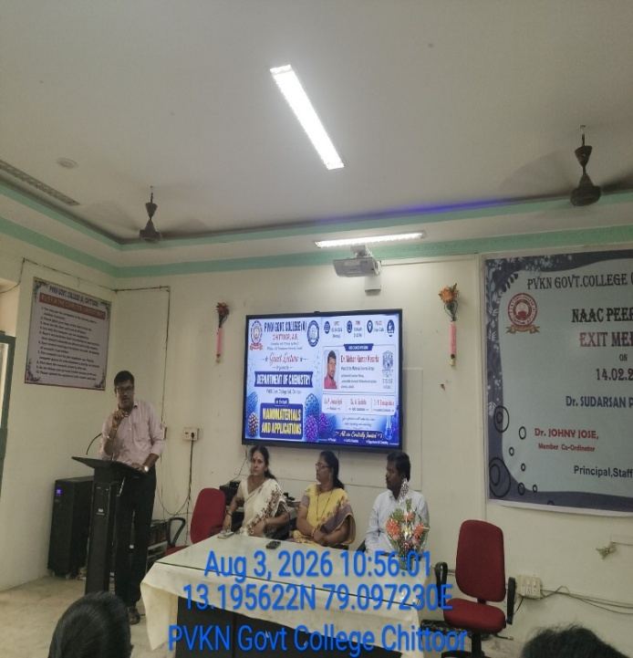
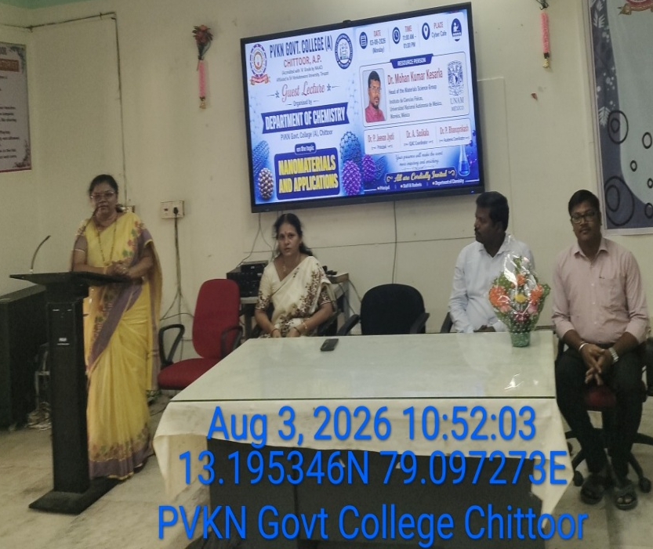
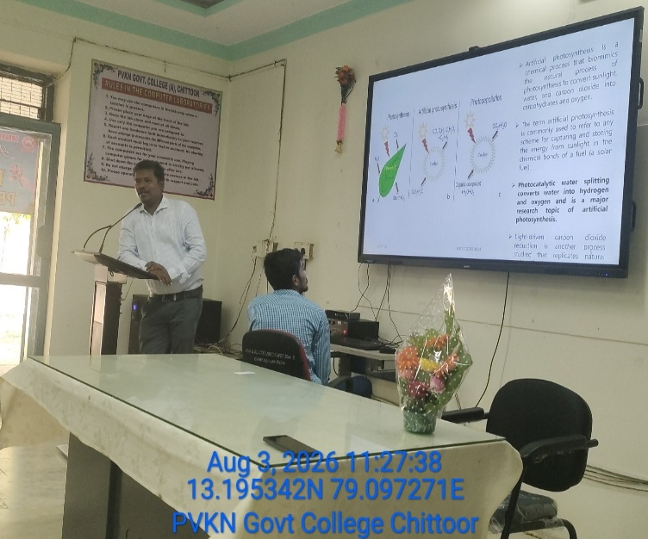
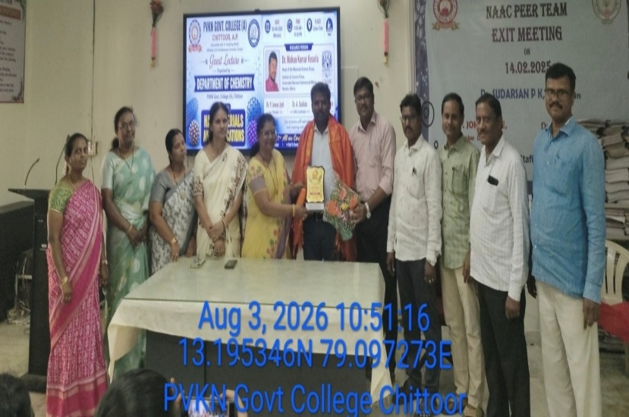
- Develop an interest in interdisciplinary research and innovation.

Raising Awareness among Youth about 'My Bharat'
Collector Sumit Kumar emphasized the need to create awareness among the youth regarding 'My Bharat' initiatives. He spoke at the 'My Bharat' District Advisory Committee meeting held at the Collectorate on Wednesday 04-08-2026. He stated that for the youth to play a pivotal role in the nation's development, they must be provided with appropriate opportunities, skill development programs, and avenues for voluntary service. He called for the successful implementation of 'My Bharat' programs through the coordinated efforts of government departments, educational institutions, and voluntary organizations. The annual action plan for 'My Bharat' for the years 2026–2027 was also discussed. District Youth Officer Pradeep Kumar, 'My Bharat' Program Supervisor G. Srinivasulu, District Advisory Committee member Harish Kalvakunta, PVKN College NSS Program Officer Dr. G. Rajesh Kumar, along with officials from various departments and representatives from educational institutions, participated in the meeting.
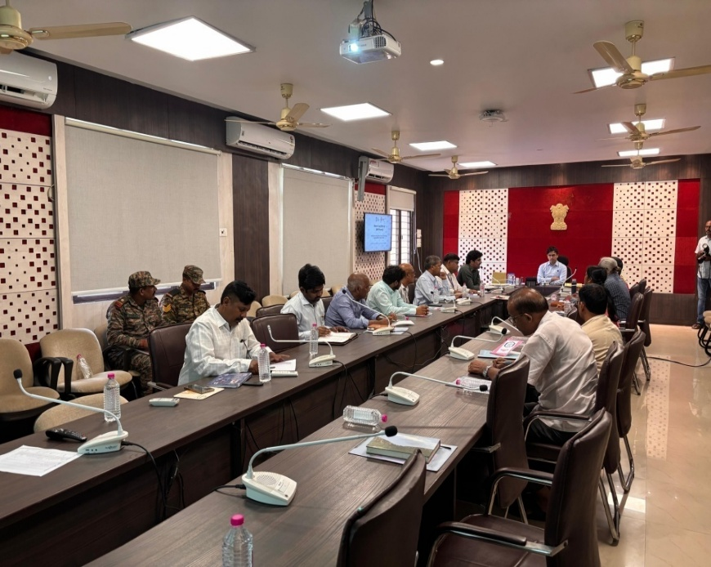

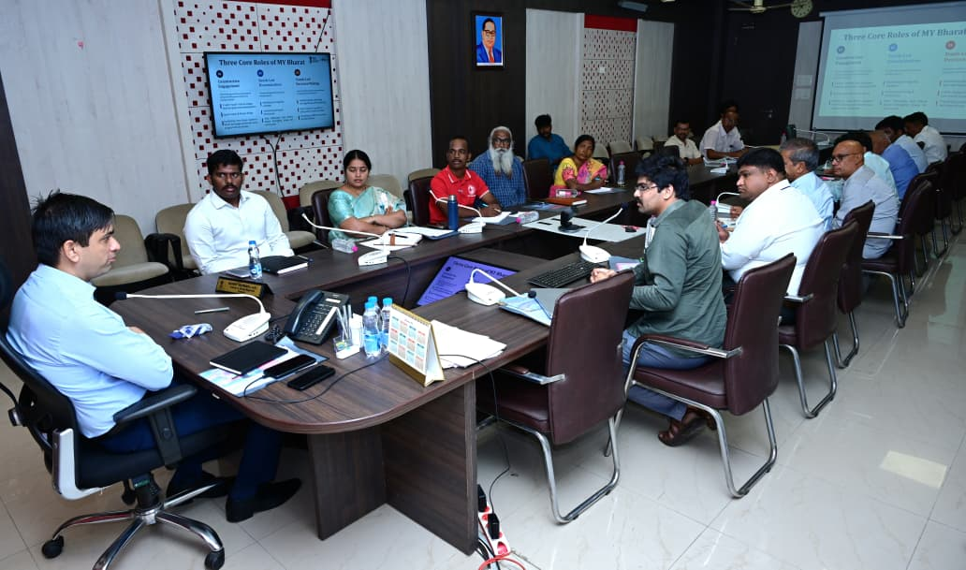

Anti Drug Awareness: Youth for a Drug-Free India

“SAY NO TO DRUGS TODAY AND SAY YES TO A BRIGHT TOMORROW”
The National Coordination Committee for Drugs (NCORD) organized an awareness programme titled “Say No to Drugs Today and Say Yes to a Bright Tomorrow” at PVKN Government College (A), Chittoor on 11-8-2026 in collaboration with the Brahma Kumaris – Medical Division, Chittoor Branch.
Dr. P. Jeevan Jyoti, Principal and District Nodal Officer, Chittoor District, addressed the students on anti-drug awareness and preventive measures. Representatives of Brahma Kumaris, Chittoor District, also addressed the students on the harmful effects of drug abuse and the importance of preventive measures.
The programme was conducted with the objective of creating awareness among students about the harmful effects of drug abuse and addiction and to encourage them to lead healthy, responsible and productive lives. The programme emphasized the importance of staying away from drugs and making positive choices for a bright future.
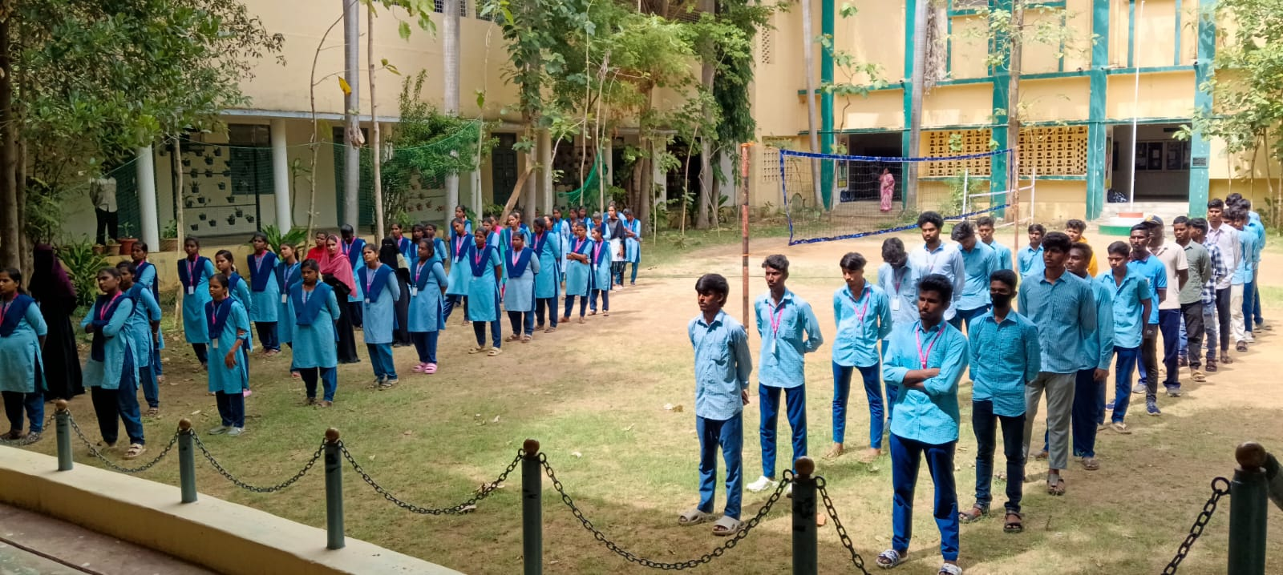
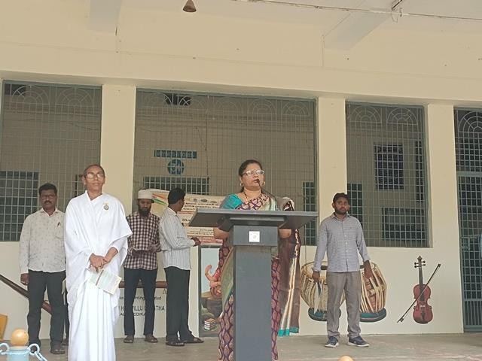
The speakers highlighted the physical, psychological, social and academic consequences of drug addiction. Students were encouraged to develop self-confidence, positive thinking and healthy habits and to act as responsible members of society by spreading awareness about the dangers of drug abuse. As part of the programme, Anti-Drug Awareness Pamphlets were distributed among the students. The Principal, faculty members, representatives of Brahma Kumaris and students participated in the pledge.
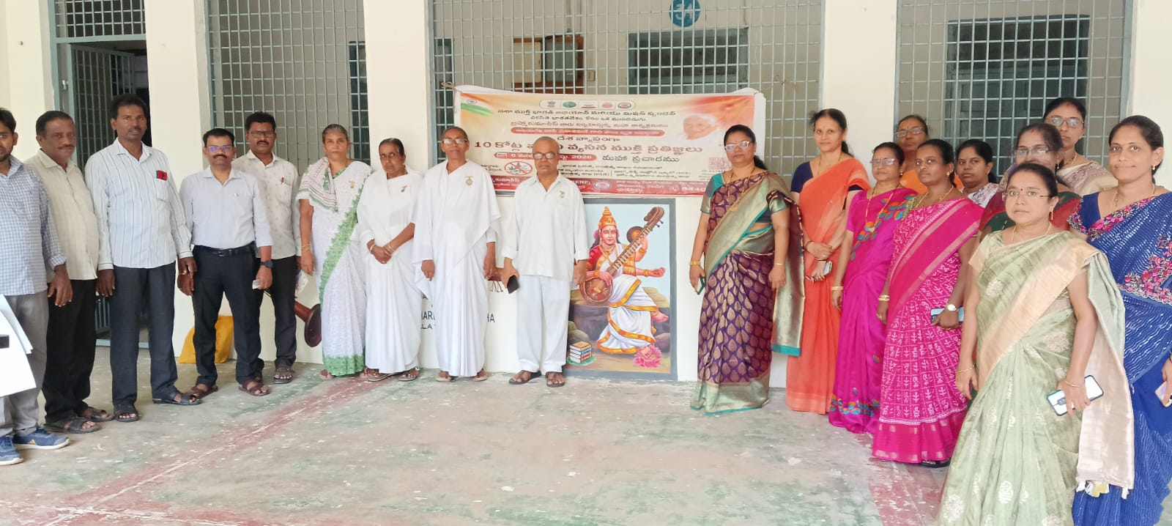
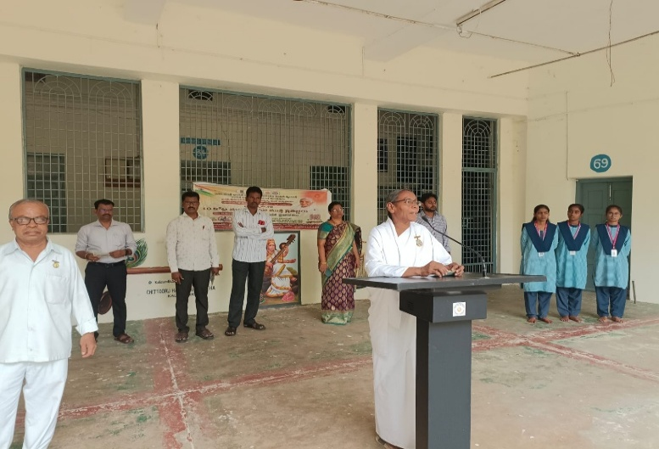

HAR GHAR TIRANGA RALLY
PVKN Government College (A), Chittoor, organized a “Har Ghar Tiranga Rally” on 13-8-2026 to promote patriotism, national unity, and respect for the National Flag among students and the public.
The programme was actively participated in by the Principal, Vice-Principal, teaching and non-teaching staff, and students of the college. The rally was conducted with great enthusiasm, with students carrying the National Flag and raising patriotic slogans. The rally created awareness about the importance of the Tiranga and encouraged everyone to show pride and respect towards the nation.
On this occasion, the Principal addressed the students and emphasized the importance of patriotism, national unity, and responsible citizenship. The Principal encouraged the students to develop a strong sense of love and respect for the country and to actively participate in activities that promote national integrity and unity.
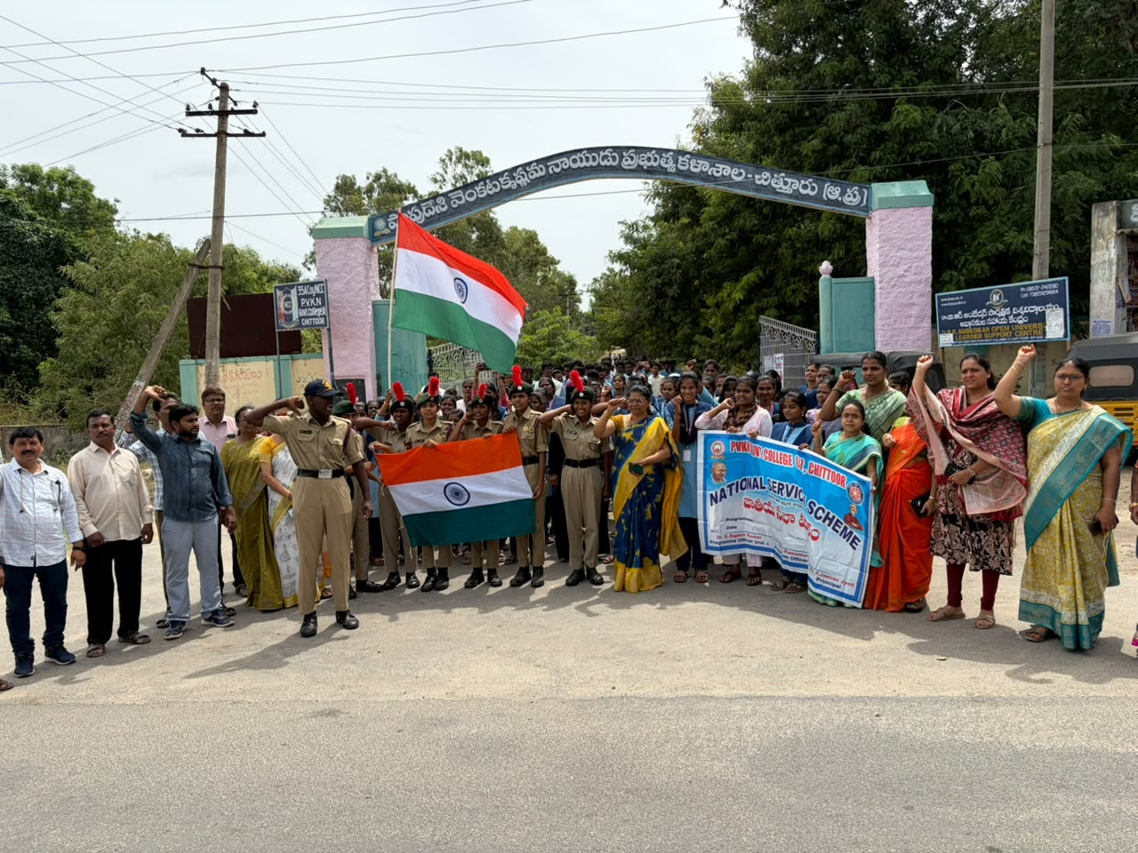
The rally concluded successfully with the participation of the staff and students. The programme created a strong feeling of patriotism, unity, and national pride among all the participants.

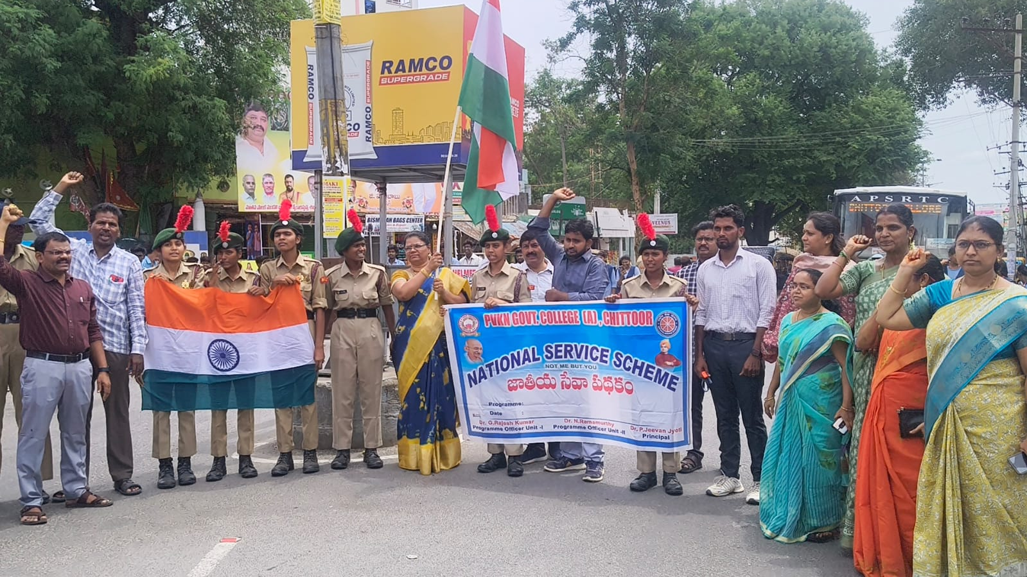

ESSAY WRITING COMPETITION:“ROLE OF AI IN BUILDING A VIKSIT BHARAT BY 2047”
PVKN Government College (A), Chittoor conducted an Essay Writing Competition for students on the topic “Role of AI in Building a Viksit Bharat by 2047.”
The competition was organized with the objective of encouraging students to understand the growing importance of Artificial Intelligence (AI) and its potential contribution towards making India a developed nation by the year 2047. Students actively participated and expressed their views on the applications of AI in various fields such as education, healthcare, agriculture, industry, governance, transportation, defence and scientific research.
Through their essays, students highlighted how the responsible and innovative use of AI can improve productivity, create new employment opportunities, support economic growth and contribute to the overall development of the country. They also discussed the need for ethical use of AI, data privacy, skill development and responsible technological innovation.
The competition provided an excellent platform for students to develop their creative thinking, writing skills, awareness of emerging technologies and vision for the future of India. The active participation of students made the programme successful and meaningful.
The programme concluded with appreciation for all the participating students and encouragement to continue developing knowledge and skills in emerging technologies.

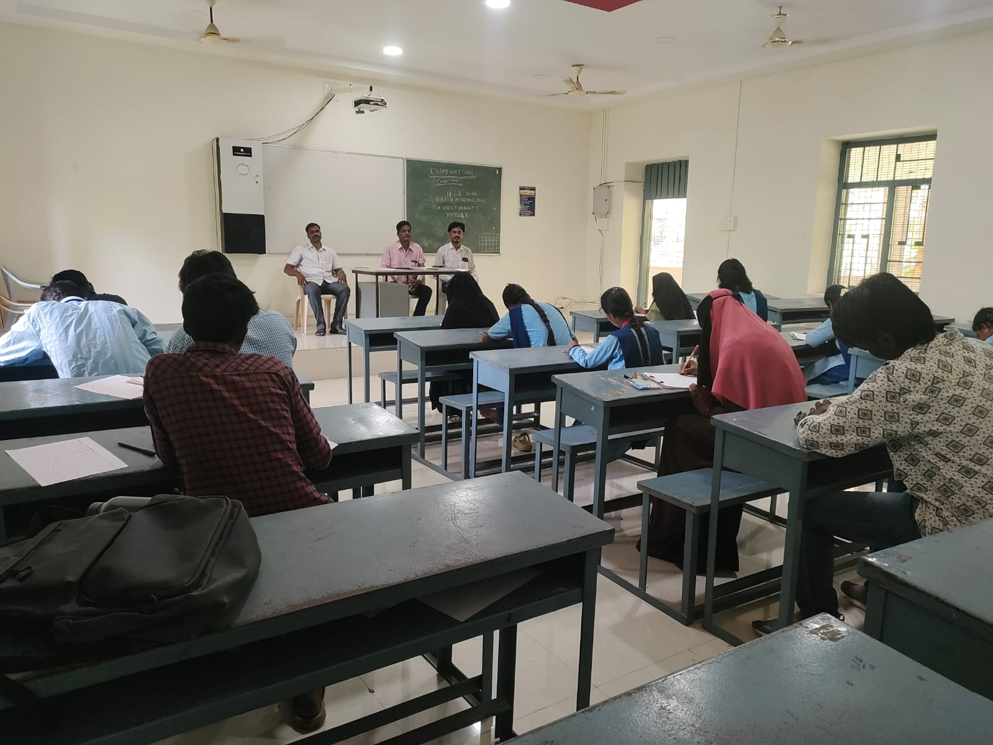

Independence Day Celebrations

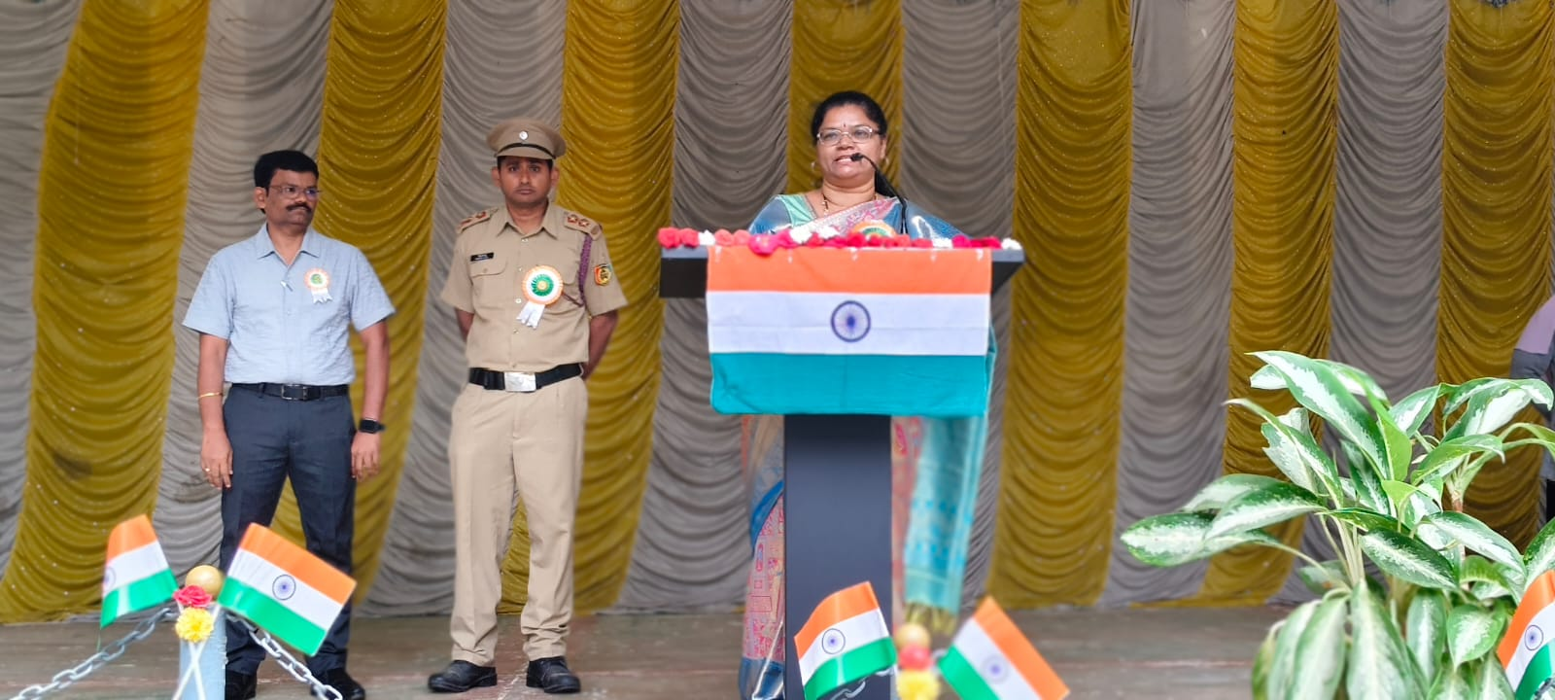
PVKN Government College, (A) Chittoor, celebrated the 80th Independence Day on 15 August 2026, marking the completion of 79 years since the country gained independence. As part of the national celebrations, the Prime Minister hoisted the national flag at the Red Fort in Delhi and addressed the nation. College Principal Dr. P. Jeevan Jyoti noted that while the first Independence Day was celebrated on August 15, 1947, the year 2026 marked the 80th celebration. At the college, the Principal hoisted the national flag. IQAC Coordinator Dr. A. Sasikala mentioned that, for the first time, the 'Vande Mataram' song was sung during the official Red Fort ceremony, she urged everyone to remember the freedom fighters who sacrificed their lives for the nation's independence and to follow in their footsteps. Subsequently, prizes were awarded to the winners of the essay writing and elocution competitions held on the occasion, and sweets were distributed to the students. Vice-Principal Dr.P.Jayachandhurdu ,NCC officer A.Ramesh and NSS Programme Officer Dr.G.Rajeshkumar spoke that Independence Day in India is celebrated every year on 15August to mark the country’s freedom from British rule in 1947.It is a National day that honours the sacrifices of freedom fighters and celebrates liberty, unity and democracy. College faculty members along with the students participated in the event.
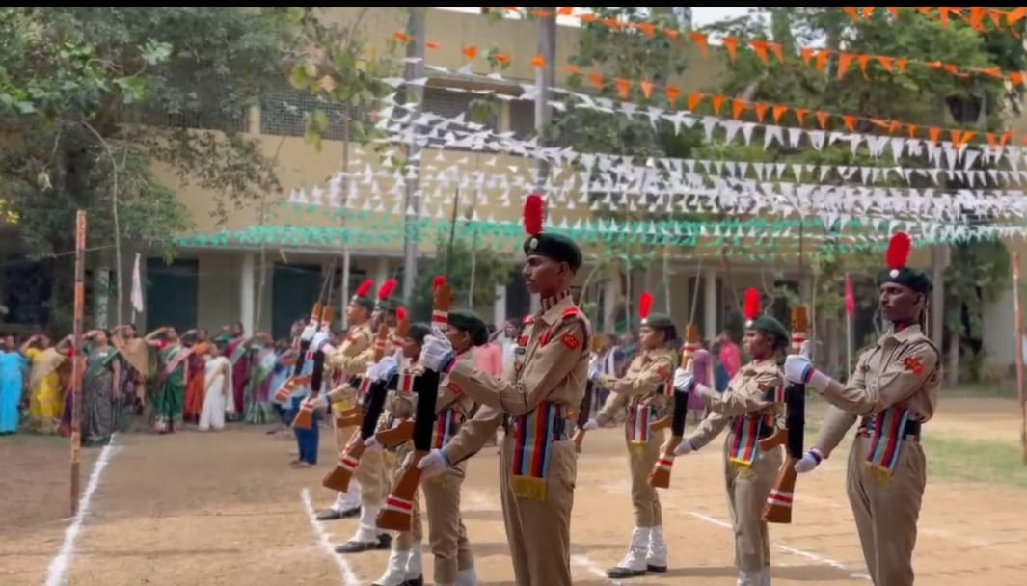

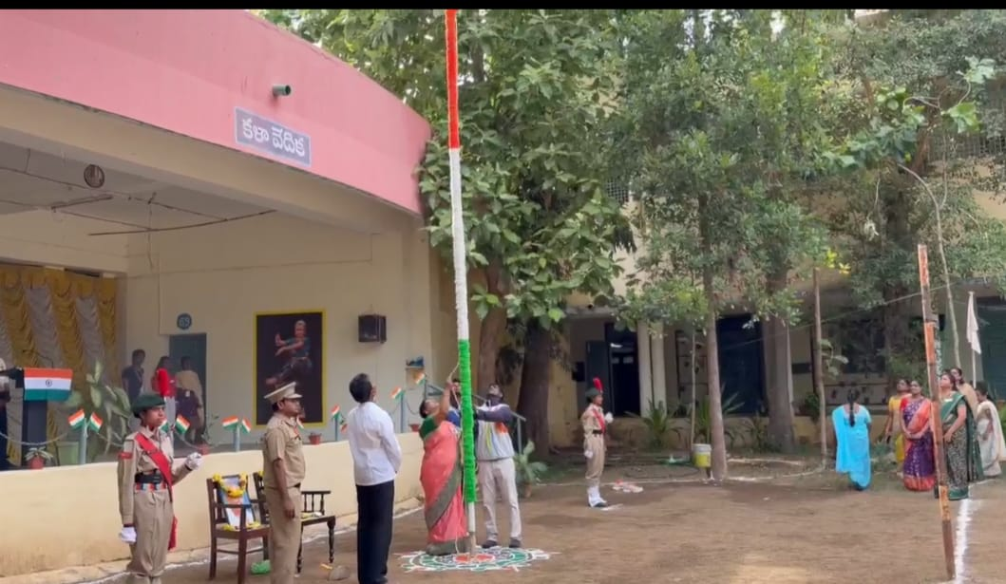

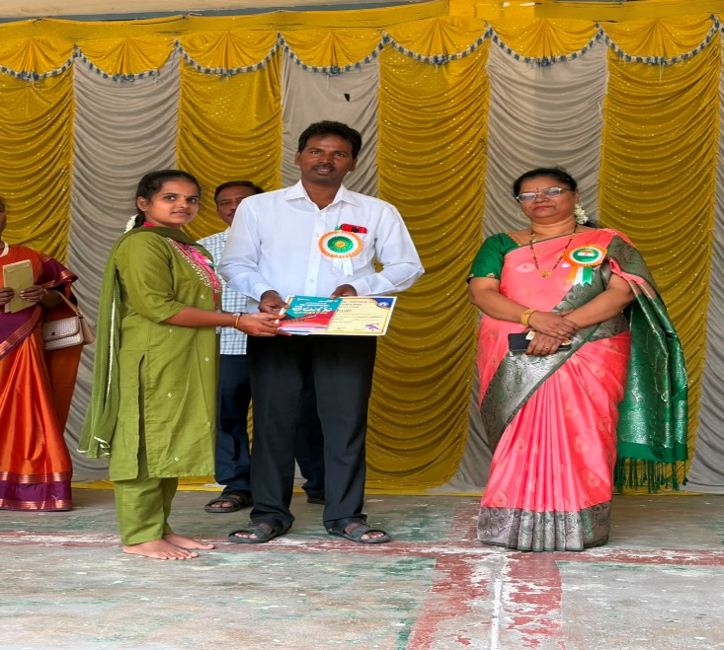
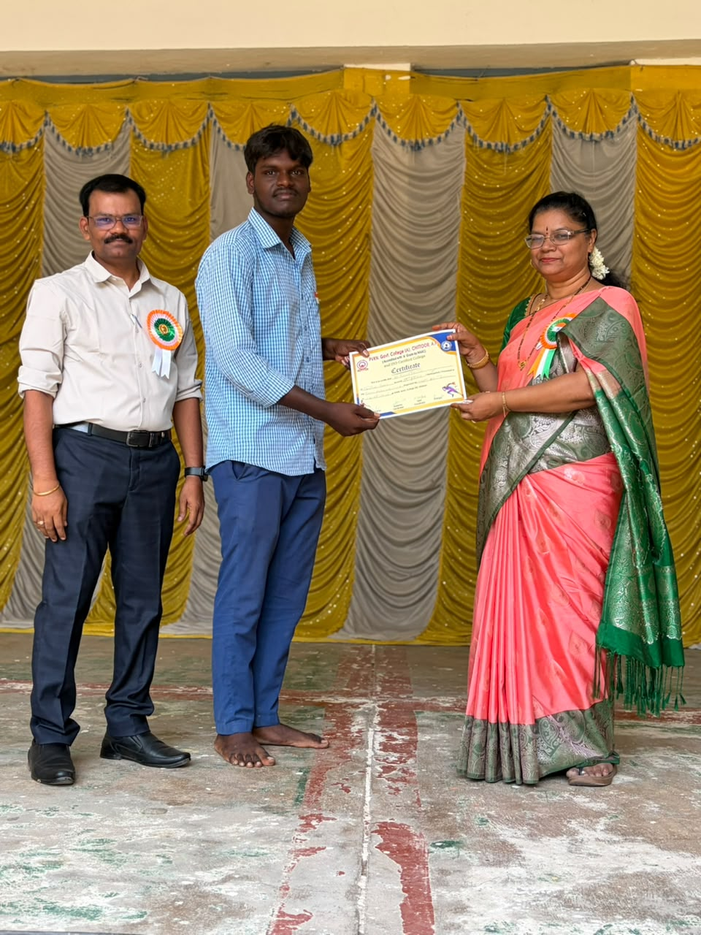
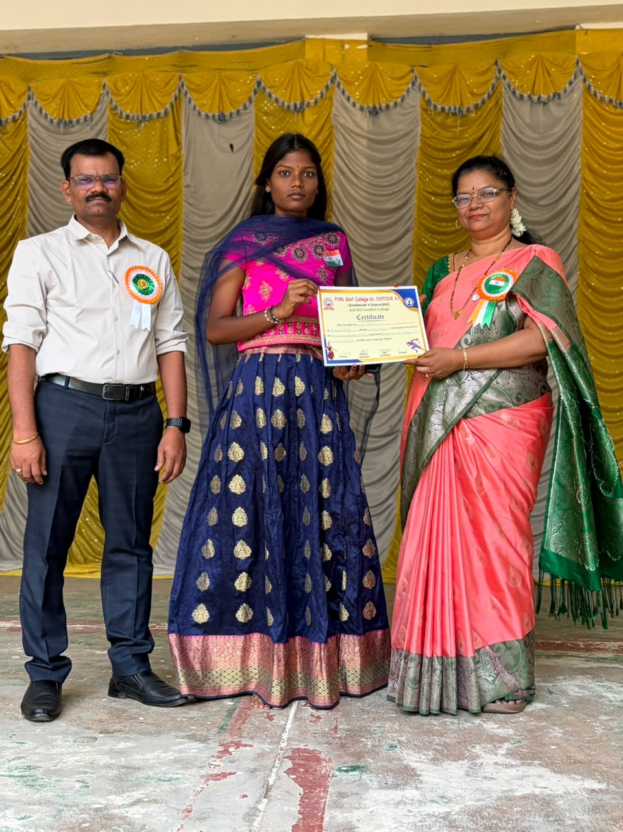

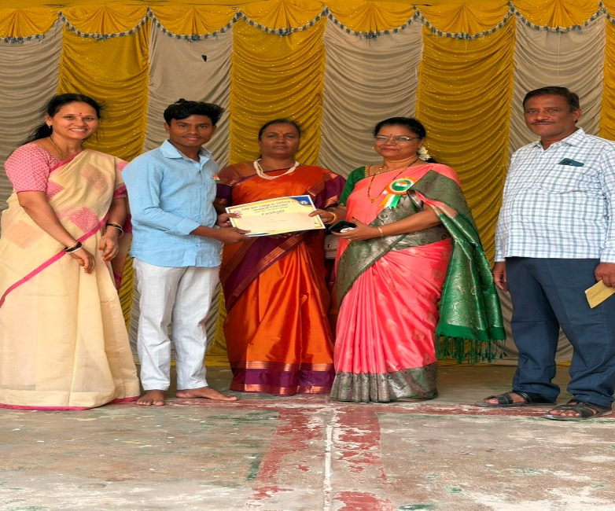

Orientation Programme on Apprenticeship
The Department of Commerce organized an Orientation Programme on Apprenticeship for the students of II B.Com (BFSI) on 18/08/2026. The programme was conducted by Smt. Sandhya Rani with the objective of creating awareness among students about apprenticeship opportunities and their importance in developing practical skills and gaining industry exposure.
During the programme, students were briefed about the concept of apprenticeship, its benefits, eligibility criteria, opportunities available in various sectors, and the role of apprenticeships in enhancing employability. The resource person also highlighted the importance of acquiring practical knowledge alongside academic education, particularly for students pursuing Banking, Financial Services and Insurance (BFSI).
The session was interactive and informative, and students actively participated by raising questions and clarifying their doubts. The programme helped students understand how apprenticeship opportunities can bridge the gap between classroom learning and professional experience.
The programme concluded with a vote of thanks to the resource person and all the participants. Overall, the orientation programme was useful in guiding students towards better career opportunities and preparing them for the requirements of the BFSI sector.

PROGRAMME OUTCOMES
- Understand the concept, purpose and importance of apprenticeship in higher education and career development.
- Gain awareness of various apprenticeship opportunities available in the BFSI and related sectors.
- Understand the eligibility criteria, application process and benefits of apprenticeship programmes.
- Recognize the importance of practical training and industry exposure alongside academic learning.
- Develop awareness of the skills and competencies required for employment in Banking, Financial Services and Insurance.
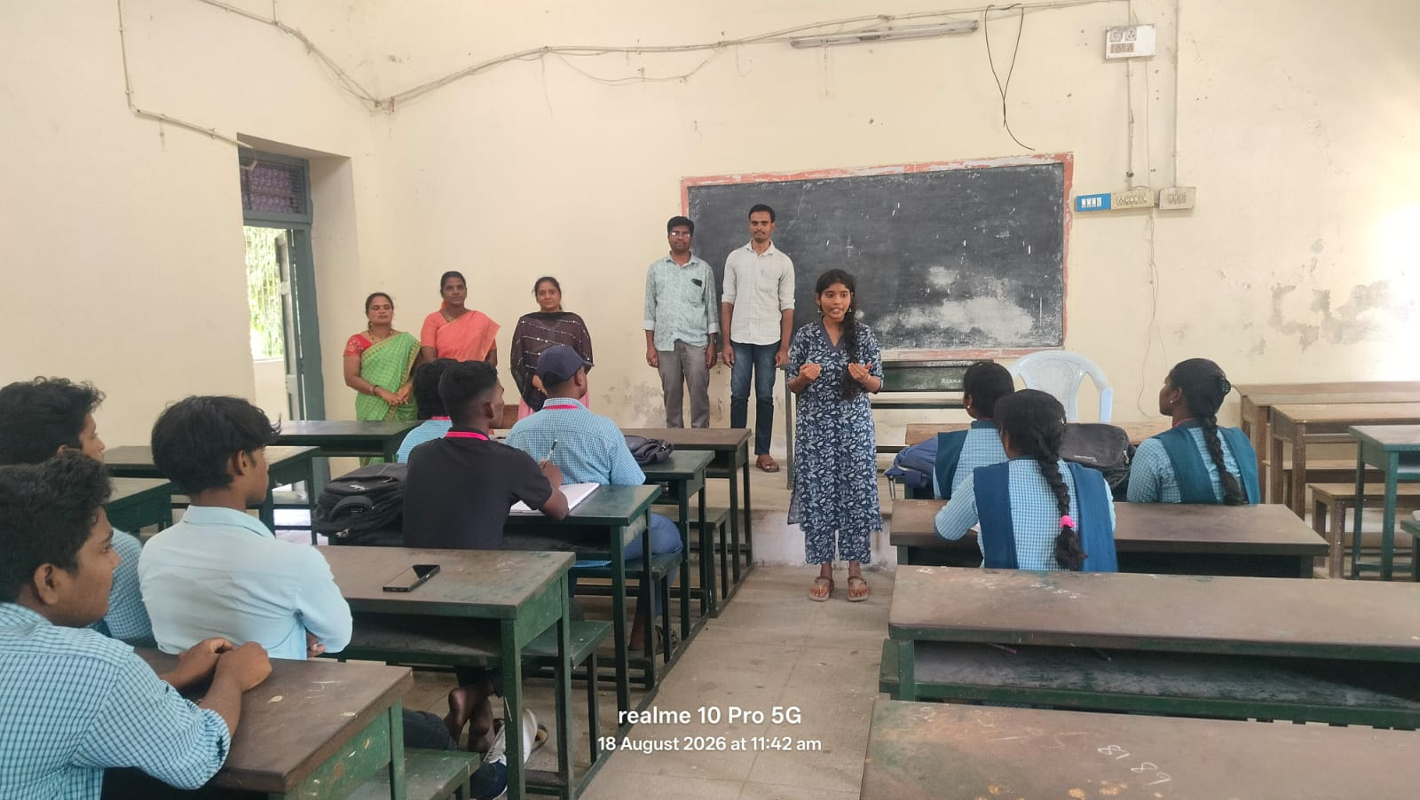
- Improve their career planning and employability prospects through apprenticeship opportunities.

“Swachha- Andhra Swarna-Andhra (SASA) : Clean and Green
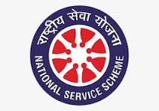
DATE:-22-08-2026
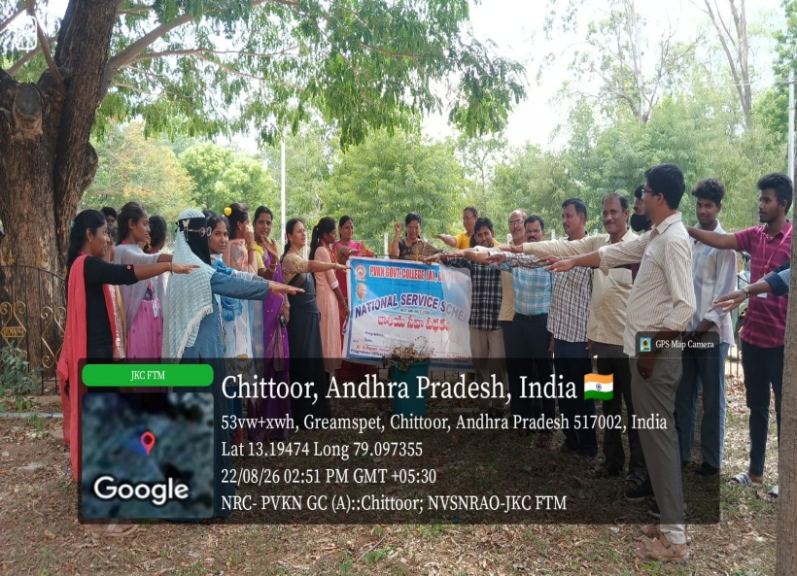
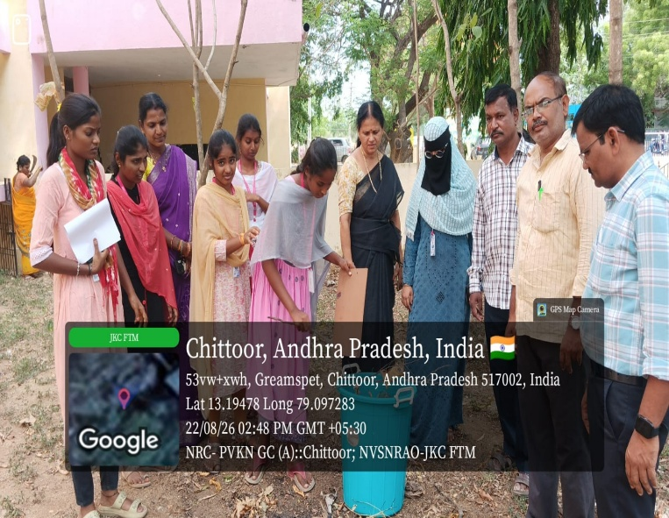
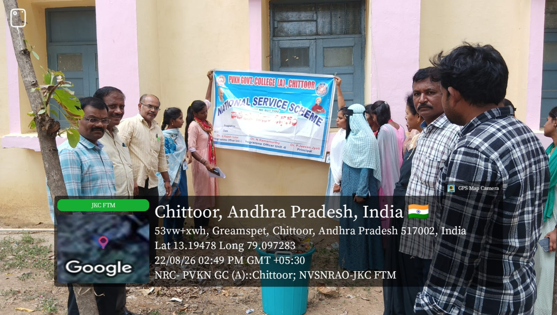
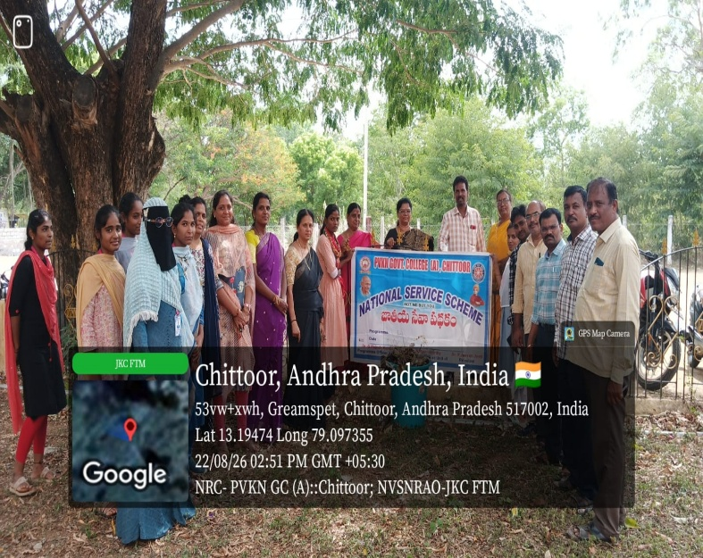
PVKN Government College (A) Chittoor. As part of the "Clean and Green" Swachh- Andhra Swarna-Andhra program of the Andhra Pradesh government on the third Saturday of every month, a Clean and Green program was organized in the college under the auspices of NSS. The program was presided over by the college principal Dr. P. Jeevan Jyoti and he said that in order to have a healthy environment, it is necessary to clean the surroundings. He said that unhealthy conditions do not occur when the surroundings are clean. Also, NSS Programme officers Dr. G Rajesh Kumar ,Dr.M. Hemalatha and IQAC Co-ordinator Dr.A. Sesikala spoke and made the students aware about waste management and environmental protection. NSS volunteers and college students organized a program called "Clean and Green" in the college. College Vice Principal Dr. P.Jayachandhrudu as well as Senior faculty Dr.A.Jayasankar, NCC officer Dr.L.Ramesh RRC Co-ordinator Dr.N.Ramamurthy, Dr.Jyoshna Narayana, Nirosha and students participated in this program.

Guest Lecture
Group: Second-Year Economics Students
Venue: D.S. Government Degree College for Women (A), Ongole
The Department of Economics, D.S. Government Degree College for Women (A), Ongole, organized a Guest Lecture on “Development Economics” on 22nd August 2026 for the benefit of the Second-Year Economics students.
Sri. P. Koteswara Rao, Contract Lecturer in Economics from PVKN Government Degree College (A), Chittoor, was invited as the resource person to deliver the guest lecture. The programme was organized with the objective of providing students with additional academic exposure and helping them understand the concepts and issues related to Development Economics.
During the lecture, the resource person discussed the significance of Development Economics and provided students with valuable academic insights related to the subject. The interaction enabled the students to gain a broader understanding of the topic beyond their regular classroom learning.
The students actively participated in the programme and benefited from the interaction with the resource person. The guest lecture served as a useful academic enrichment activity for the Second-Year Economics students.

Objectives
- To provide additional academic exposure to the students.
- To enhance students’ understanding of Development Economics.
- To connect classroom learning with broader economic perspectives.
- To provide an opportunity for students to interact with an experienced Economics lecturer.
- To encourage students to develop greater interest in the subject.

Outcomes
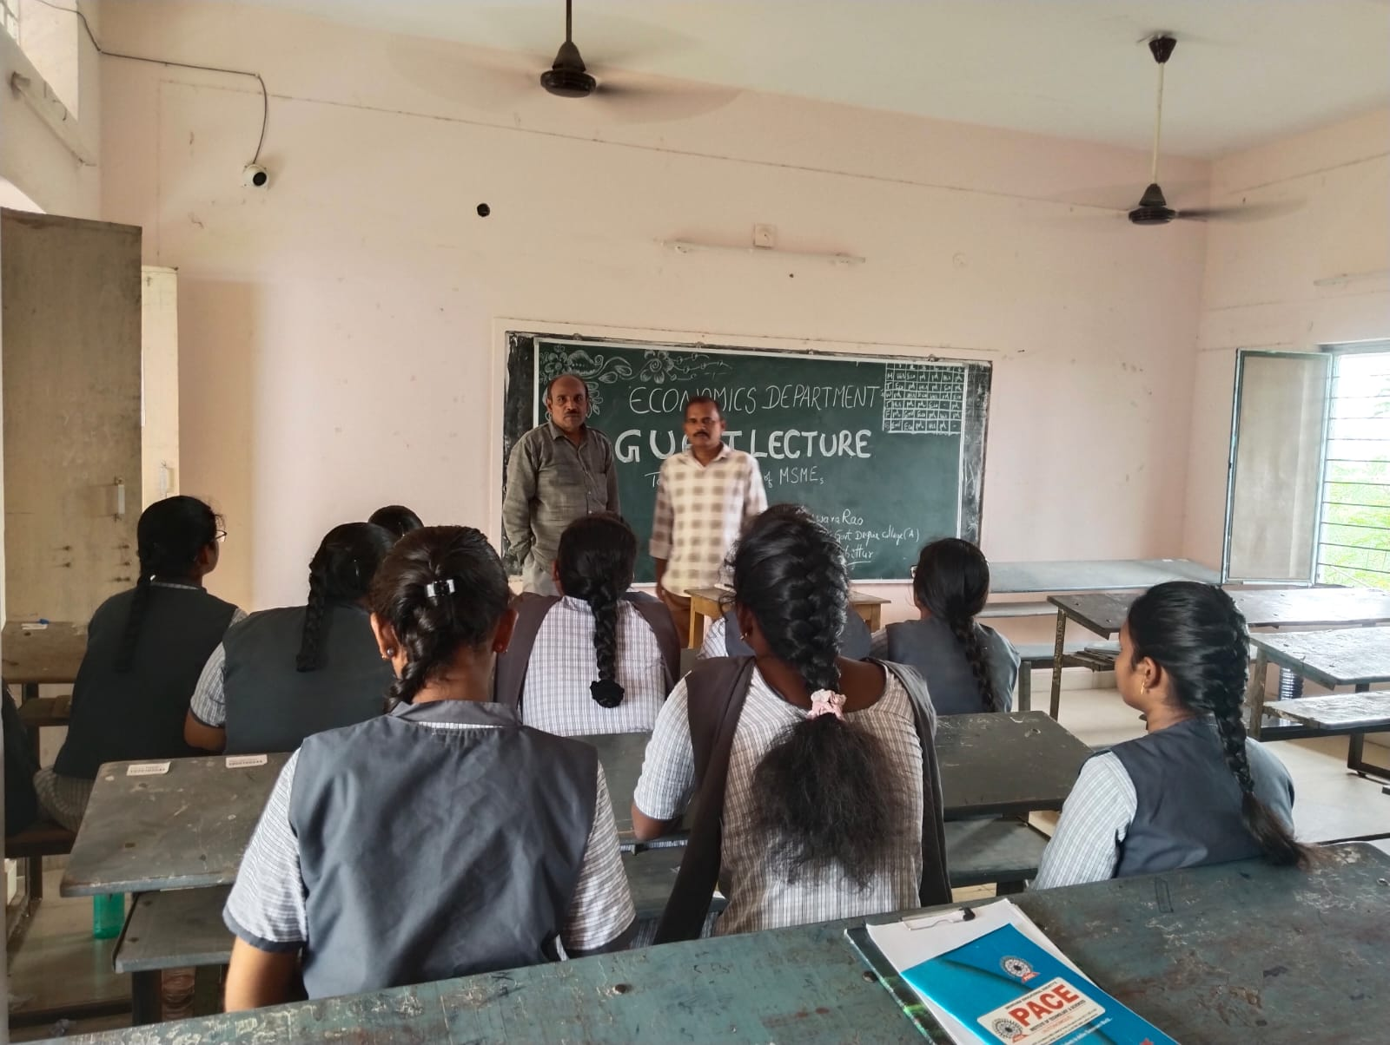
The guest lecture was academically beneficial to the students. It helped them gain additional knowledge and understanding of Development Economics and encouraged active learning through interaction with the resource person.

National Space Day Celebrations:23-08-2026
The Department of Physics & Electronics organized National Space Day Celebrations at the college level to commemorate India’s remarkable achievements in space exploration and to create awareness among students about the country’s growing leadership in space science and technology.
Highlights of the Celebration
The Principal, IQAC Coordinator, Academic Coordinator, faculty members of the Department of Physics & Electronics, and students participated in the celebrations. The Principal and coordinators addressed the students and highlighted the importance of scientific curiosity, innovation, research, and the significant role of young learners in contributing to India’s future in science and technology.
As part of the celebrations, a college-level essay writing competition was conducted on the theme “India’s Journey to the Moon: From Chandrayaan to Global Leadership.” A total of 25 entries were received from students of B.Sc., B.A., and B.Com. programmes. The competition provided students with an opportunity to express their views on India’s journey in lunar exploration, the achievements of the Chandrayaan missions, and the country’s emerging role in the global space sector.
A documentary video on the Chandrayaan missions was screened for the students, highlighting India’s significant milestones in lunar exploration. Some students also actively participated by presenting posters related to space science, the Chandrayaan missions, and India’s achievements in space exploration.
Outcome
The programme successfully created awareness among students about India’s accomplishments in space exploration and inspired them to develop greater interest in space science, scientific research, innovation, and India’s journey towards global leadership in space technology.

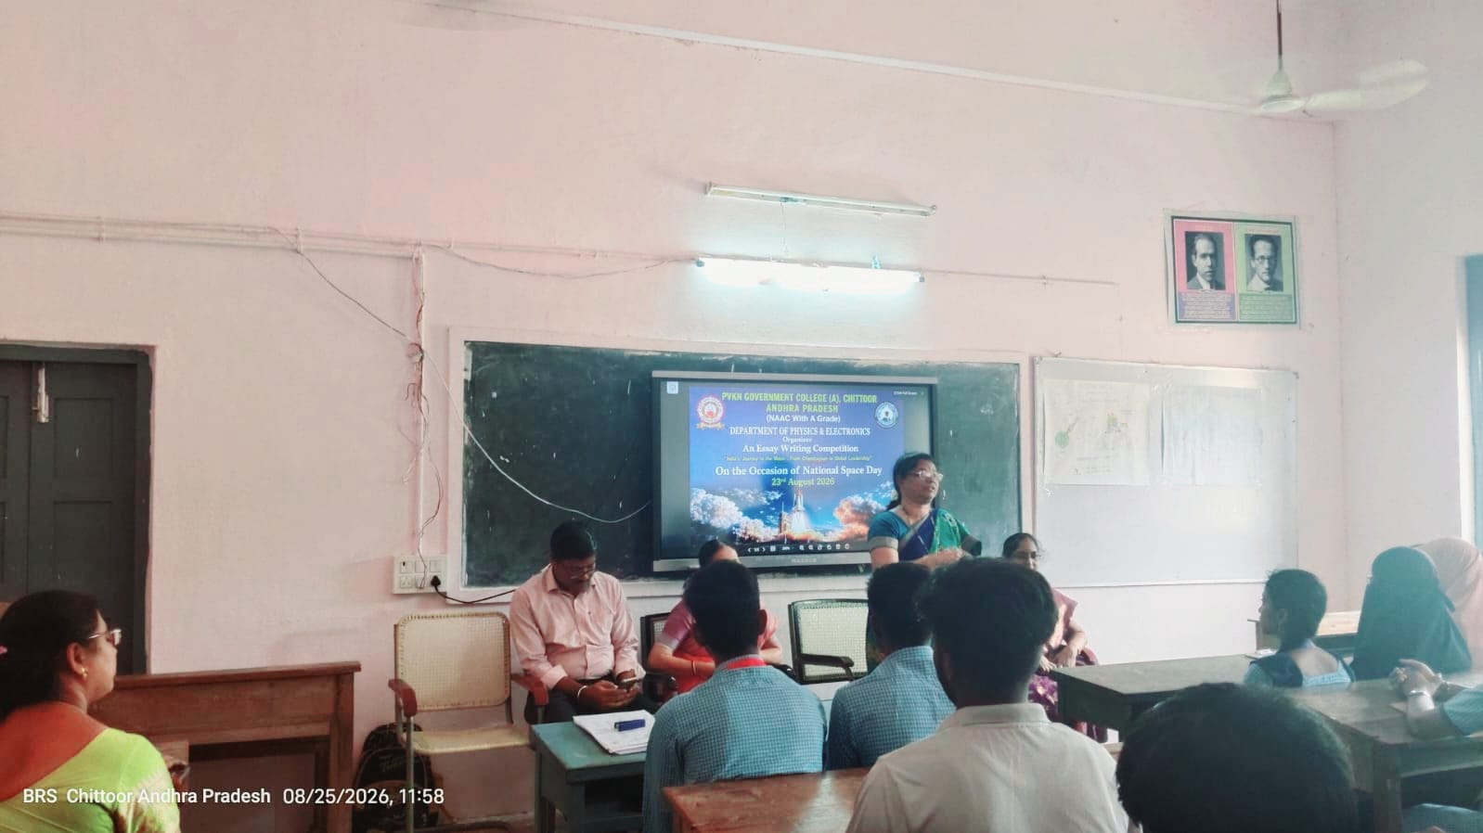

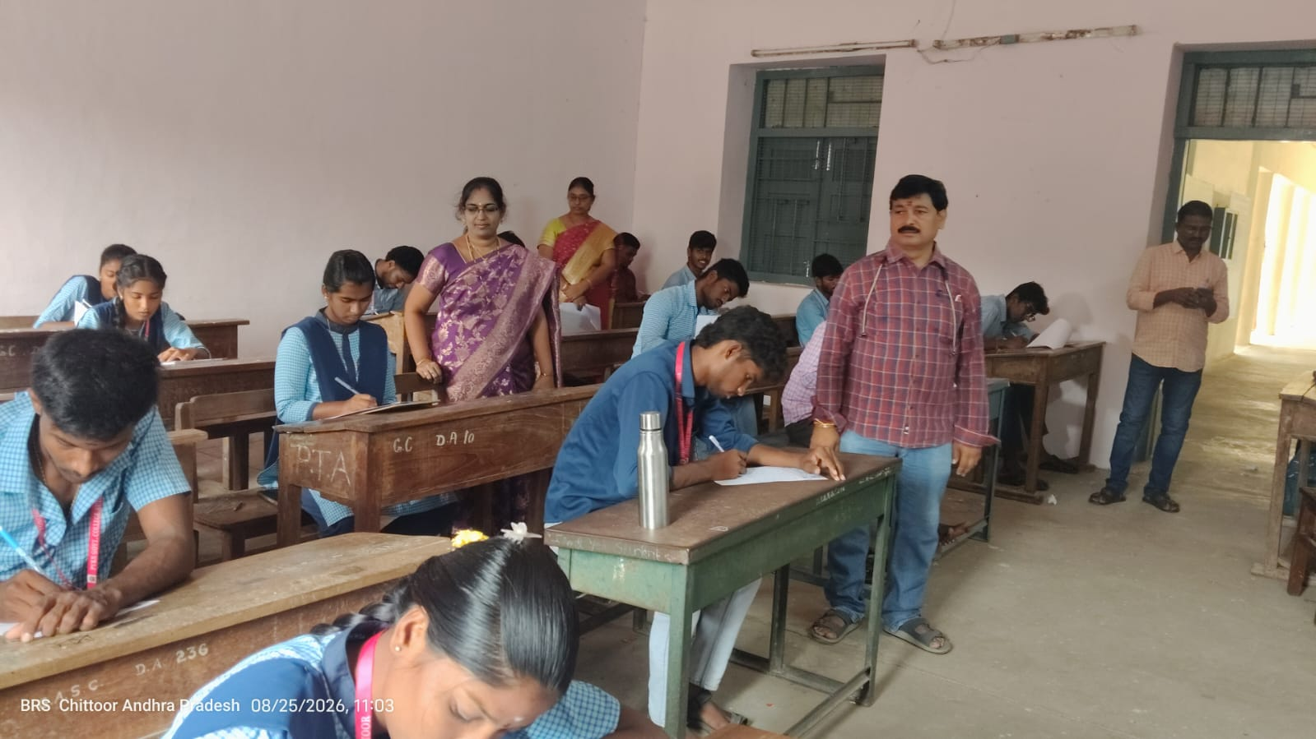

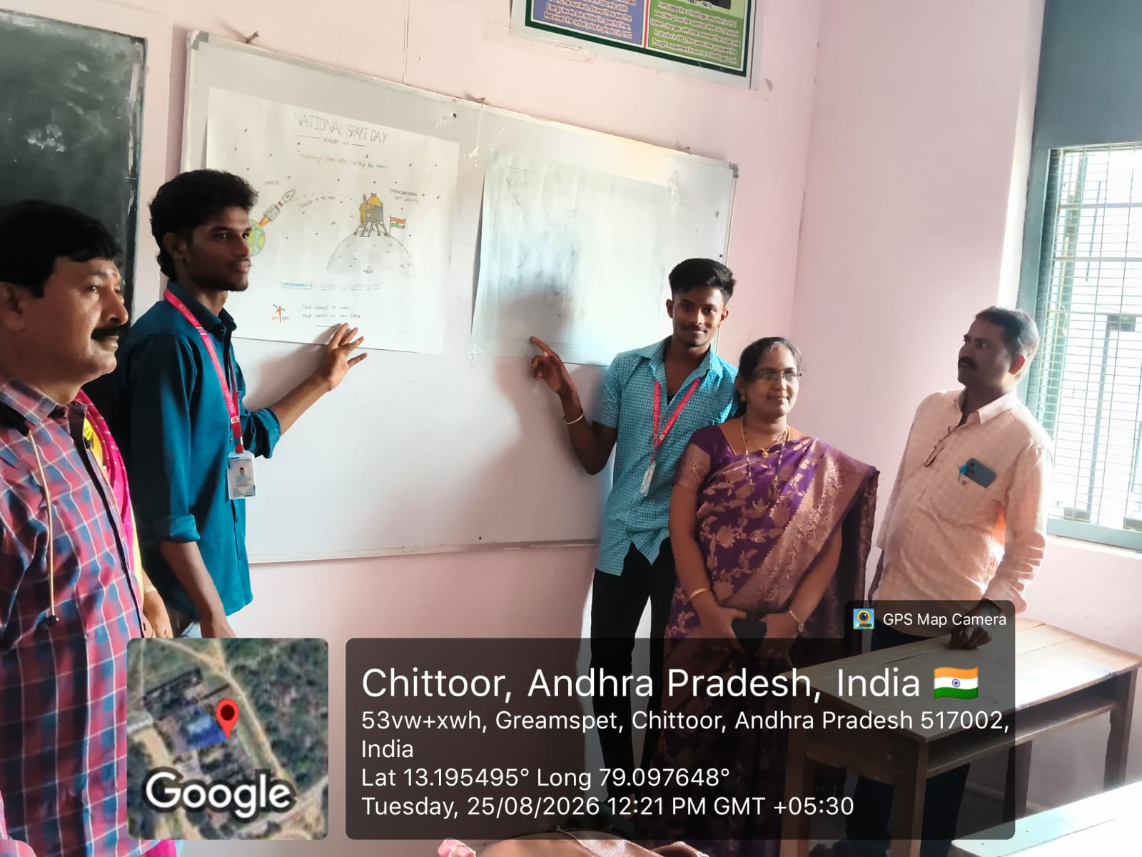

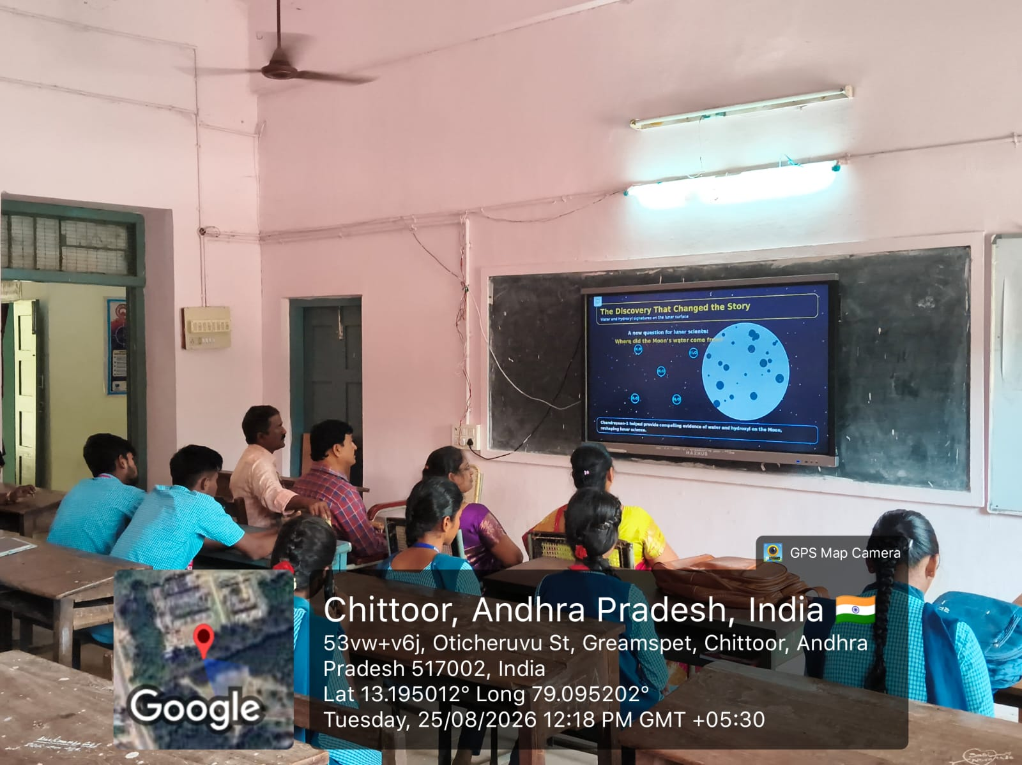

VC ON “SKILLING IN QUANTUM AND AI”
The Principal, Dr. P. Jeevan Jyoti, along with staff attended a Video Conference (VC) on “Skilling in Quantum and AI” at PVKN Government College (A),cyber cafe on 24-08-2026. The programme focused on creating awareness about the emerging fields of Quantum Technology and Artificial Intelligence (AI) and the importance of developing skills in these rapidly growing areas.
The session highlighted the significance of Quantum Technology and AI in education, scientific research, industry, healthcare, communication and other emerging sectors. The participants gained valuable insights into the future scope of these technologies and the need for students to acquire appropriate technical and problem-solving skills.
The Principal encouraged the students to make use of such programmes and develop knowledge and skills in emerging technologies to prepare themselves for future academic and career opportunities.
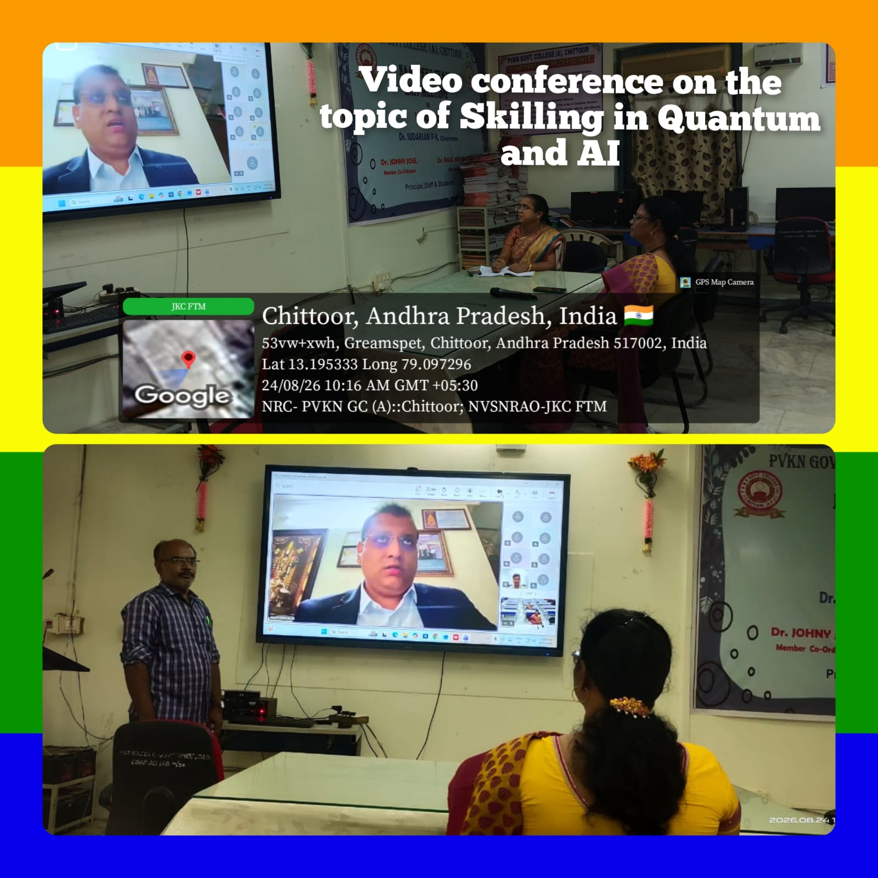
The VC was informative and beneficial to the participants. It motivated the students to explore the rapidly developing fields of Quantum Technology and Artificial Intelligence and understand their role in shaping the future.

ANTOINE LAVOISIER’S BIRTHDAY:25-8-2026
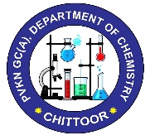
Stakeholders: Teaching staff and II and III B.Sc. students
Activity Coordinator: Dr. P. Bhanuprakash
No. of participants: 06 Chemistry Staff & 45 Students
The Department of Chemistry, P.V.K.N. Govt. College (A), Chittoor, organized a Crossword Puzzle Competition on “Antoine Lavoisier’s Contributions to Science” as part of the celebration of Antoine Lavoisier's birthday, widely regarded as the “Father of Modern Chemistry.” The programme was organized to create awareness among students about Lavoisier’s pioneering contributions to the development of modern chemistry. The crossword puzzle was designed to provide students with an engaging and activity-based learning experience. The competition focused on important concepts associated with Lavoisier, including the Law of Conservation of Mass, identification of oxygen and hydrogen, and his contributions to the understanding of combustion reactions.
Objectives:
- To familiarize students with the life and scientific contributions of Antoine Lavoisier.
- To create awareness about Lavoisier’s role in establishing the foundations of modern chemistry.
- To promote activity-based and interactive learning in chemistry.
- To develop students’ logical thinking, problem-solving, memory, and analytical skills through a crossword puzzle.
- To encourage active student participation in academic and co-curricular activities.
As part of Antoine Lavoisier's birthday celebration, the Department organized the Crossword Puzzle Competition on 25th August 2026 from 12:00 PM to 1:00 PM. The programme was followed by a PowerPoint presentation and display of a video on Lavoisier’s contributions to science at the Chemistry Seminar Hall. The activity was conducted as an interactive academic competition. Students were provided with a crossword puzzle based on significant facts, concepts, and contributions associated with Antoine Lavoisier. Participants were required to identify and correctly place the relevant terms in the crossword, thereby reinforcing their subject knowledge enjoyably. The crossword puzzle activity was specifically titled “Antoine Lavoisier’s Contributions to Science.” Dr. P. Jeevan Jyoti, Principal of the college, addressed the students on the contributions of Antoine Lavoisier to science. Students were encouraged to participate, and winners were to be recognized with prizes and certificates.

Outcomes:
- Students gained greater awareness of Antoine Lavoisier and his pioneering role in modern chemistry.
- Students strengthened their understanding of the Law of Conservation of Mass and Lavoisier’s work related to oxygen, hydrogen, and combustion.
- The crossword activity enhanced students’ recall, logical reasoning, analytical thinking, and problem-solving abilities.
- Students experienced chemistry learning through an interactive and engaging activity-based approach.
- The combination of the crossword puzzle, PowerPoint presentation, and video provided a multimodal learning experience.

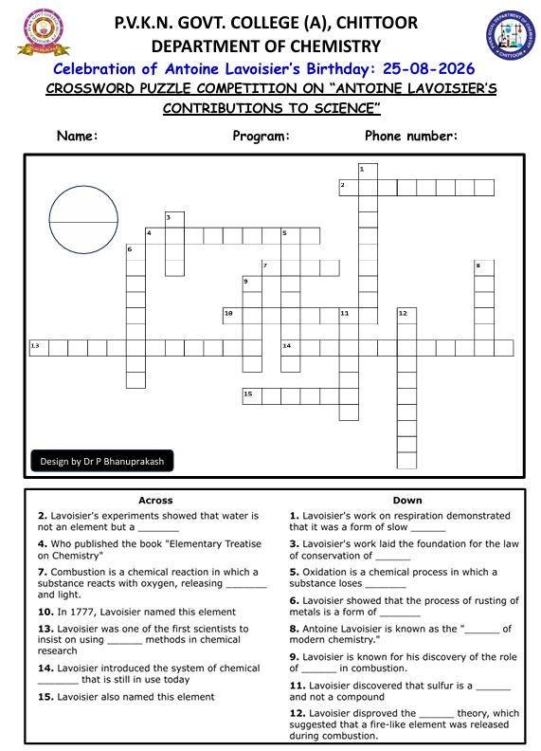
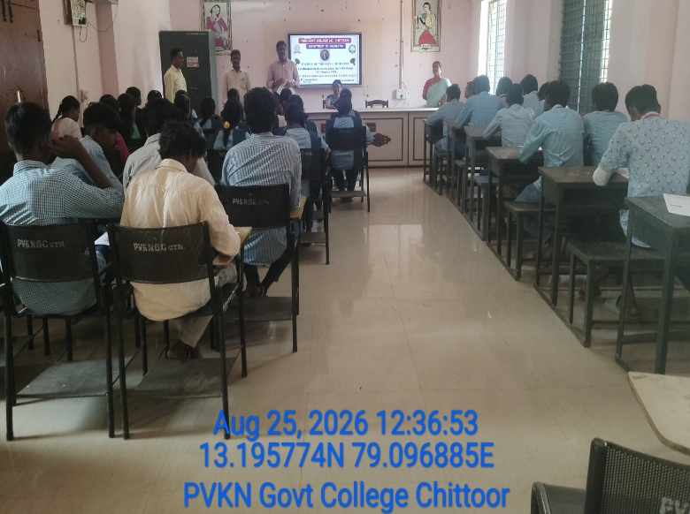
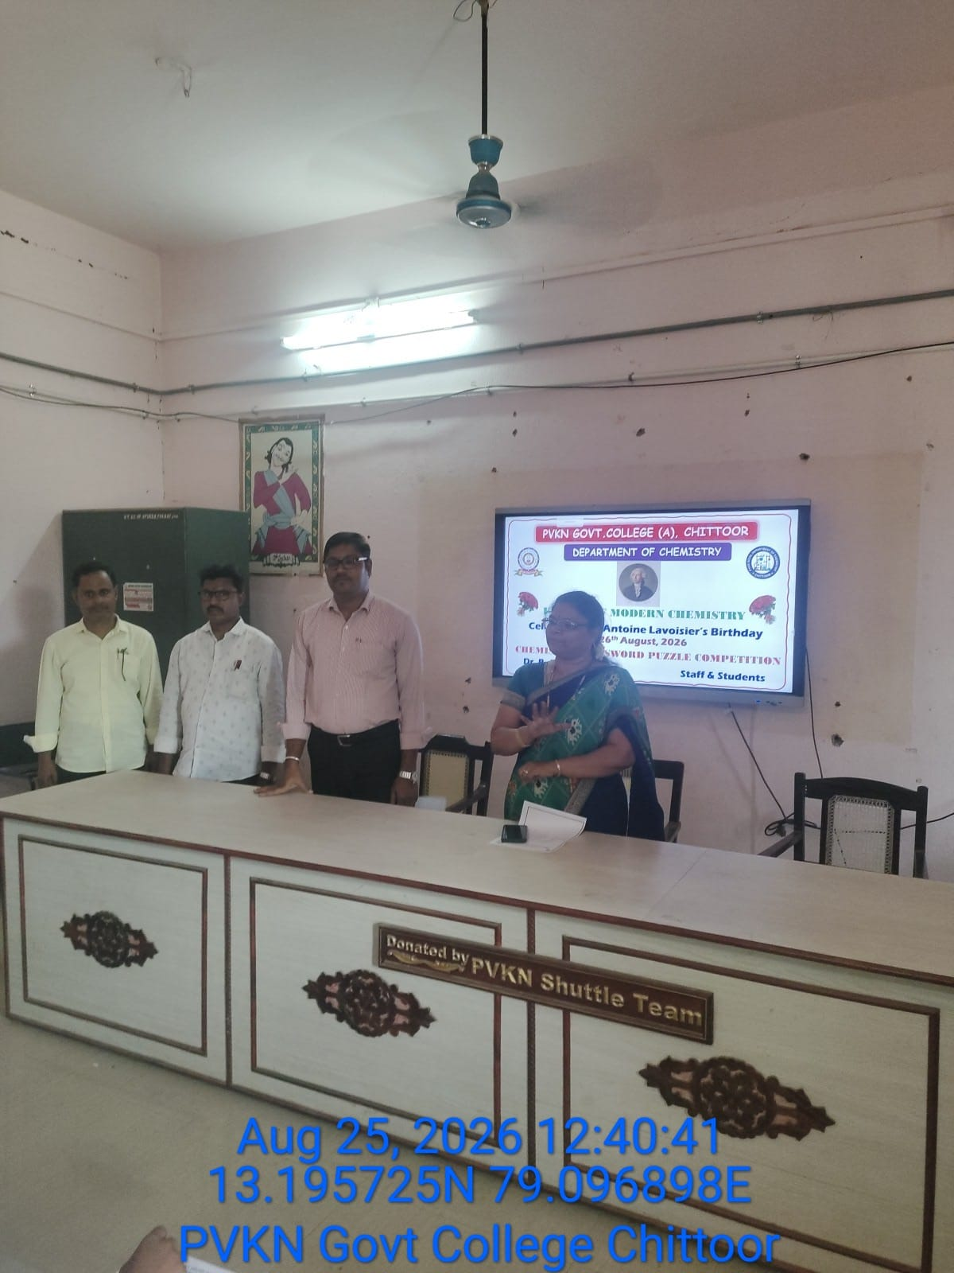
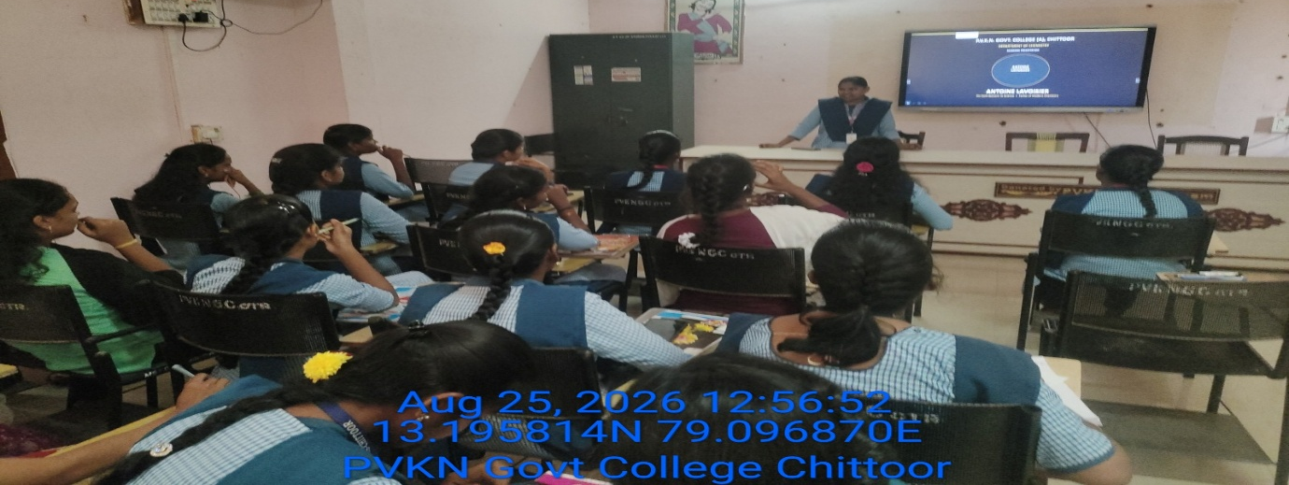
(Dr. P. Jeevan Jyoti, Principal; and Dr. P. Bhanuprakash, Academic Coordinator and Staff of department of Chemistry, addressing the students)
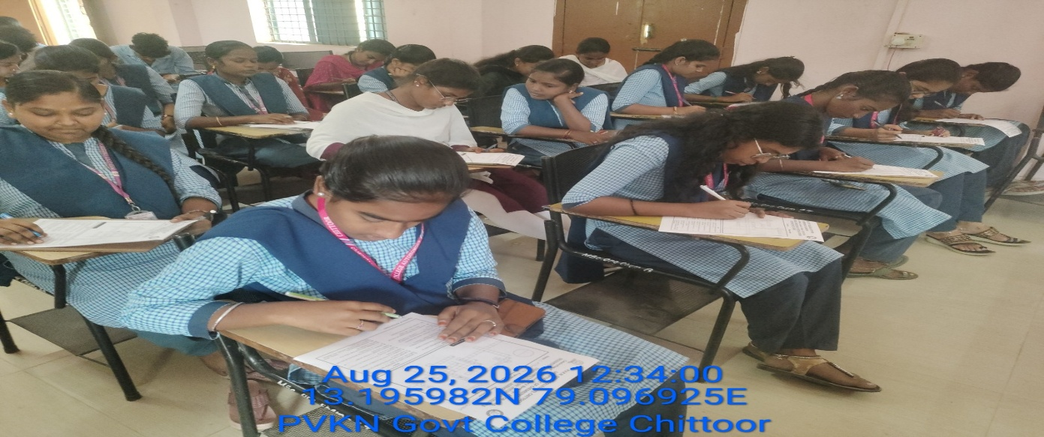
(PowerPoint presentation by students and display of a video on Lavoisier’s contributions to science)
(Students participating in a crossword puzzle based on significant facts, concepts, and contributions associated with Antoine Lavoisier)

Khelo India Samvad: 27-08-2026

Online interaction with the Prime Minister as part of 'Khelo India Samvad' under the aegis of My Bharat
The "Khelo India Samvad – Khel Ki Baat, PM Ke Saath" (Dialogue on Sports with the PM) program was organized at the local PVKN Government College, Chittoor. This event was held under the joint auspices of the Ministry of Youth Affairs and Sports (Government of India), My Bharat (Chittoor), PVKN Government College, and the NSS.
During the event, the youth interacted online with the Honorable Prime Minister, Shri Narendra Modi, sharing their thoughts, opinions, and aspirations regarding sports, youth development, health, fitness, and the role of youth in nation-building. The Prime Minister's message inspired the youth and instilled in them an enthusiasm to make sports an integral part of their lives.
Smt. Katari Hemalatha, Chairperson of CHUDA, attended the event as the chief guest. The program saw the participation of College Principal Dr. P. Jeevan Jyothi, Vice Principal Dr. P. Jayachandru, SETWIN Executive Officer Shri Yashwanth, My Bharat Program Supervisor Shri G. Srinivasulu, faculty members, NSS Program Officer Dr.G.Rajesh Kumar, program officials, My Bharat volunteers, and a large number of young people.
National-level basketball players from Chittoor, Ms. S. Kausalya and Ms. T.C., also participated in the event. Along with Sneha, athletes such as national-level medal winner Bogoju Praneeth Kumar were also introduced. The event was organized to inspire the youth through interactions with these local athletes.
During the 'Yuva Samvad' (Youth Dialogue) held on this occasion, young participants discussed their ideas, challenges, future goals, and their role in the nation's development. Organizers stated that the primary objective of such events is to foster leadership qualities, sportsmanship, patriotism, and a sense of social responsibility among the youth. 'My Bharat' volunteers Nityanandam and Poorvajain anchored the event.
Following the program, 'Youth Icon' Harish Babu raised awareness about registration on the 'Mera Yuva Bharat' portal. He also urged the youth to participate in the 'Viksit Bharat Young Leaders Dialogue' quiz and contribute their suggestions and ideas for a developed India at the national level.
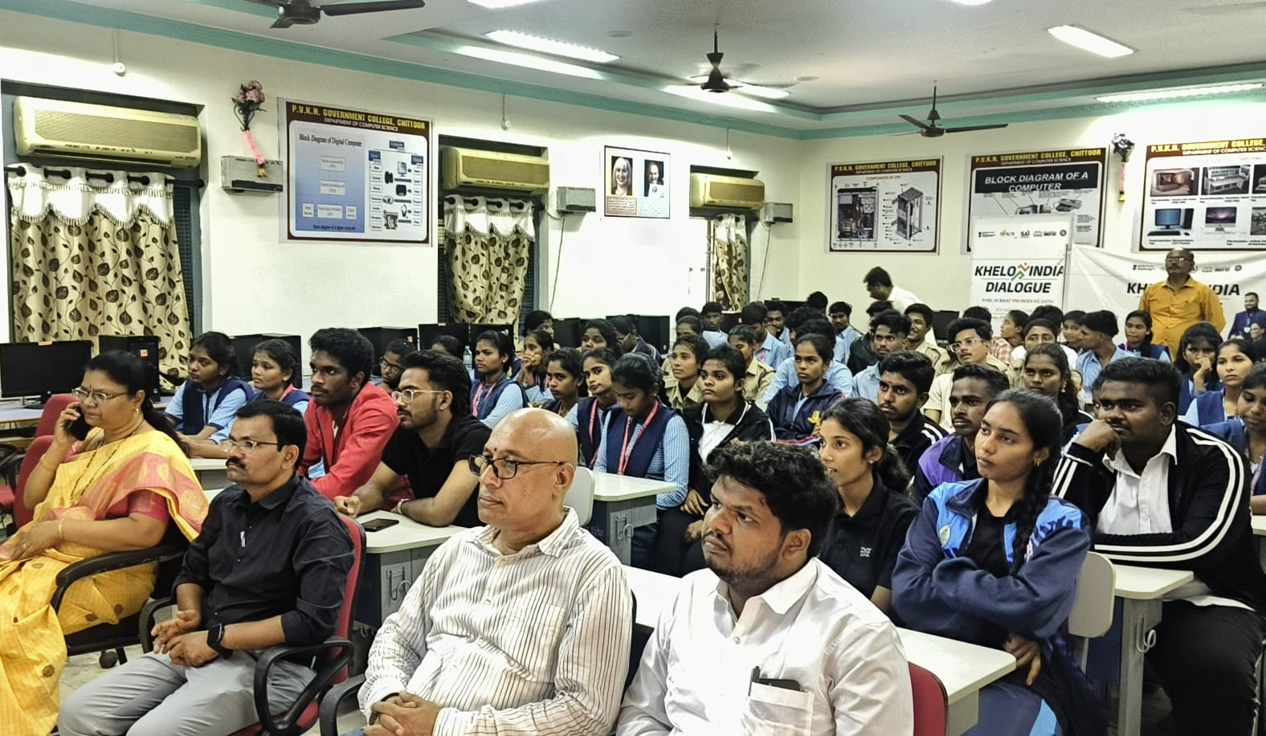
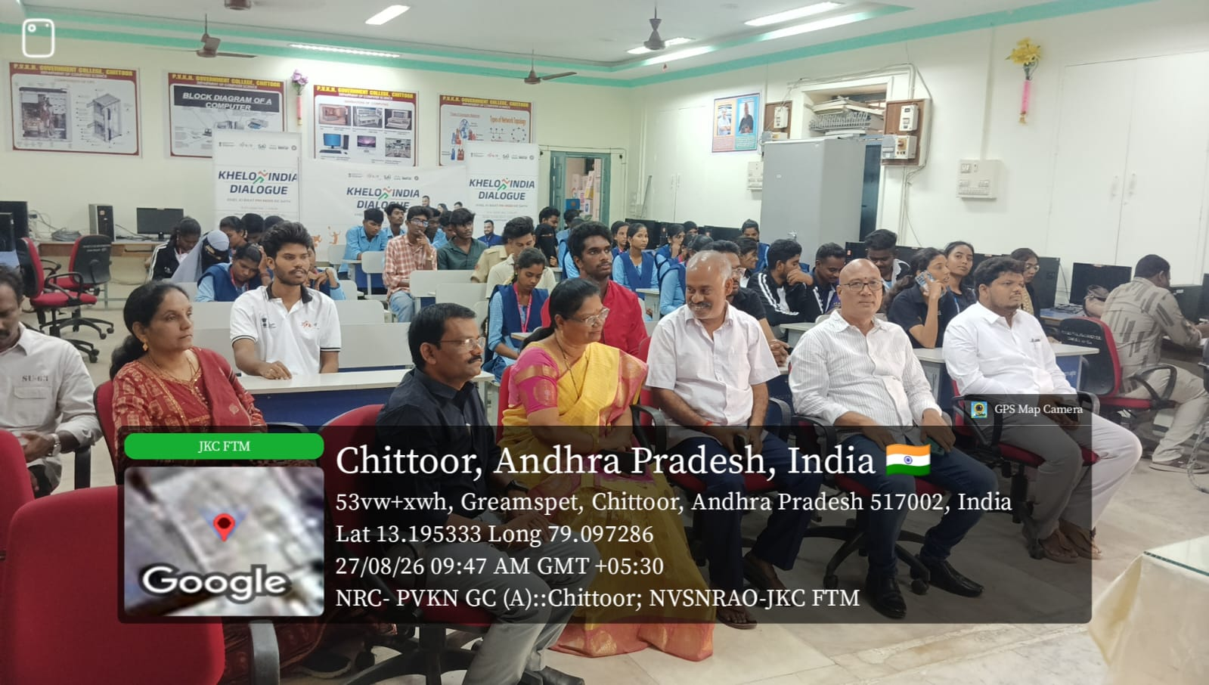
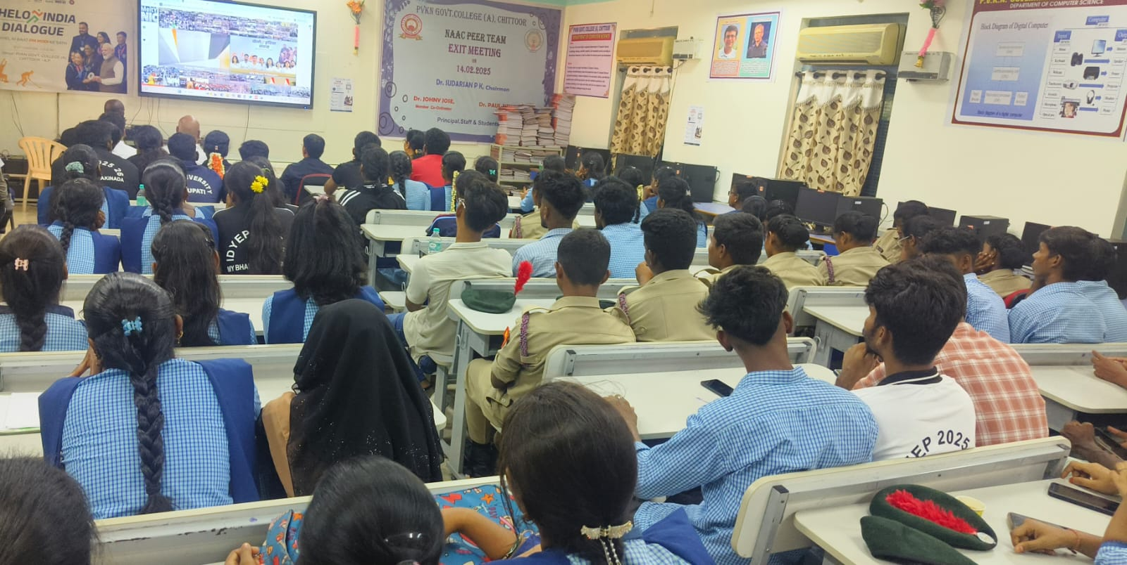

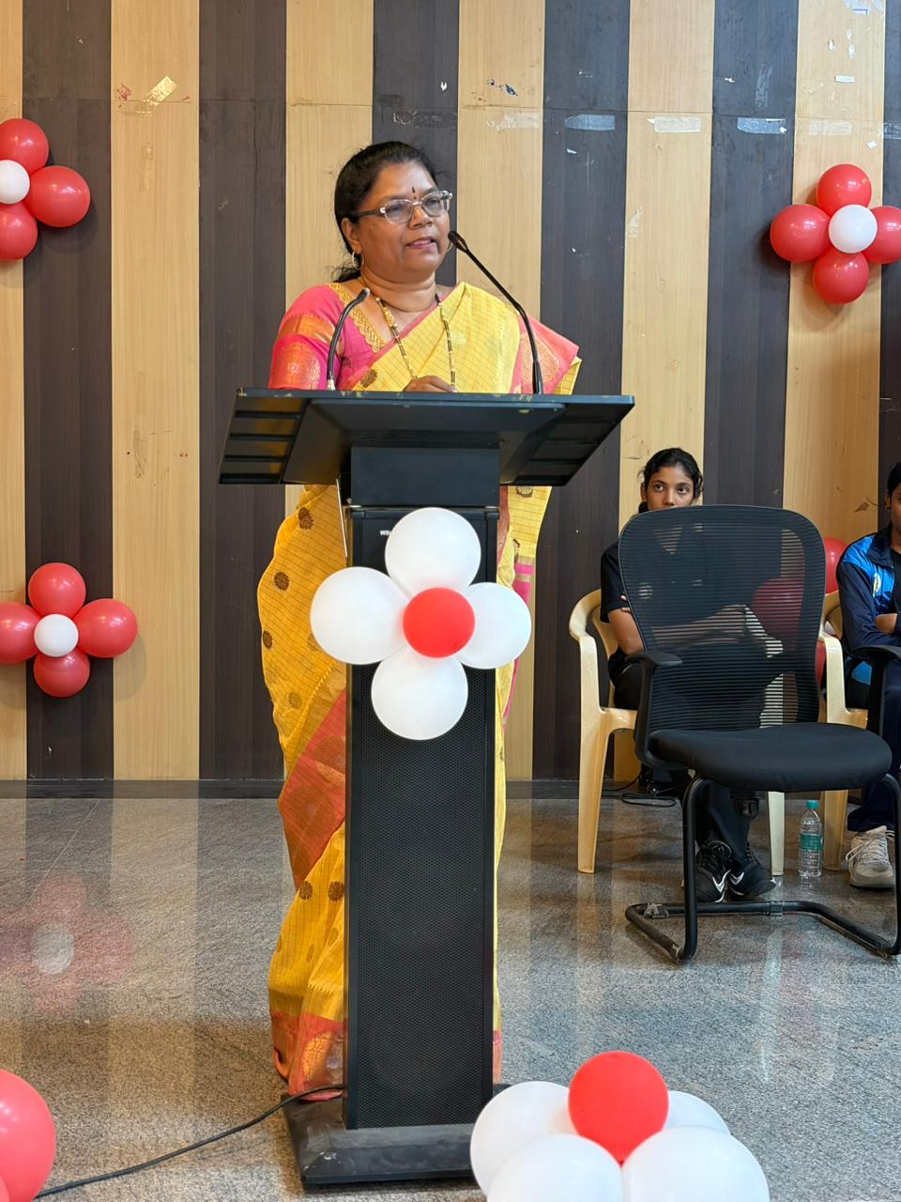
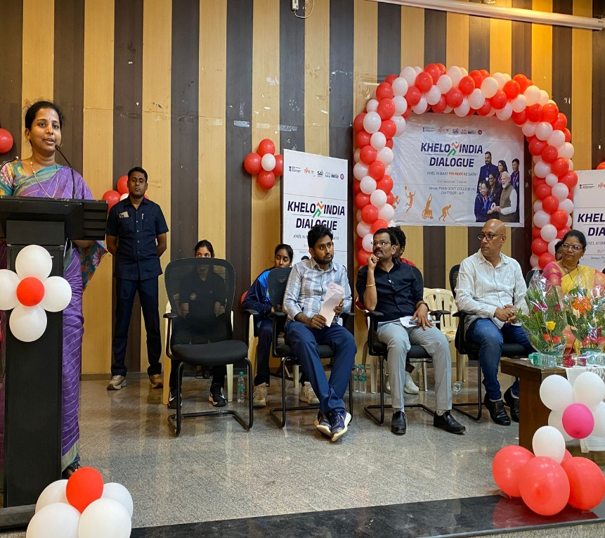

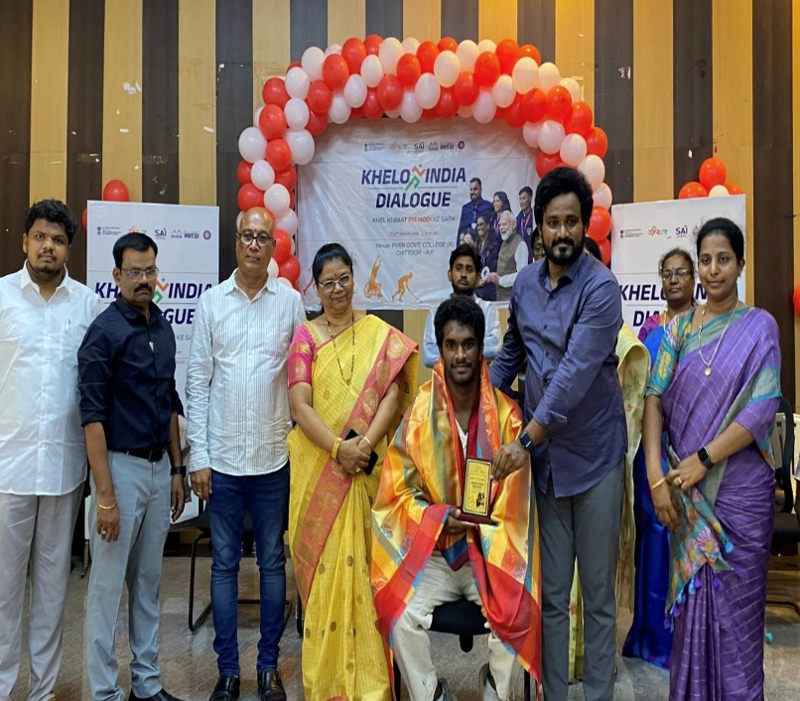
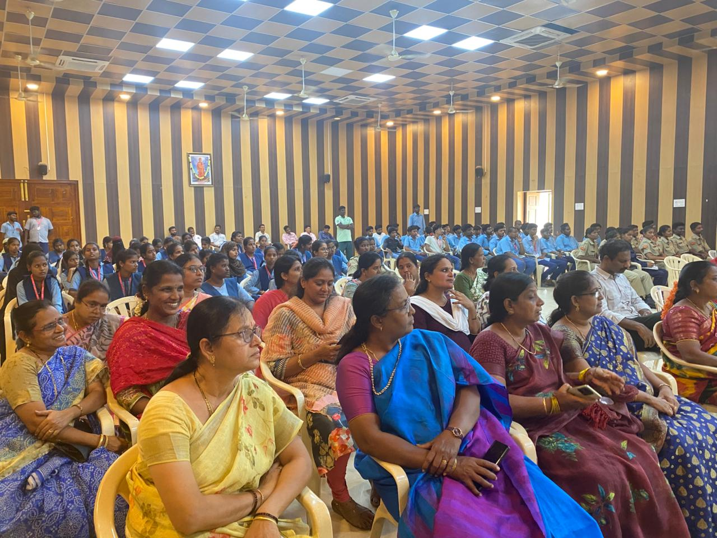
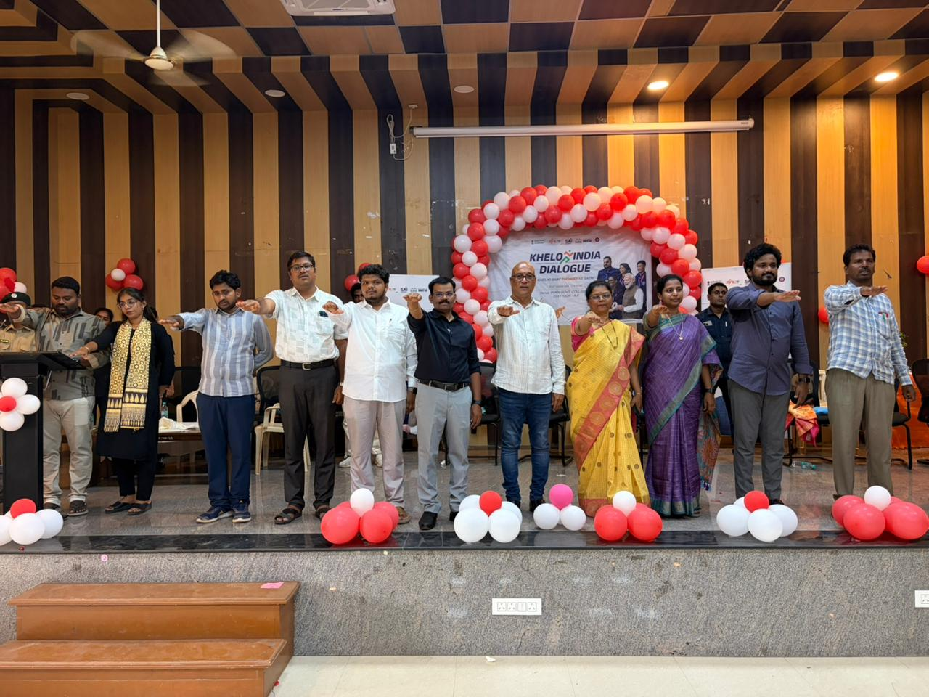
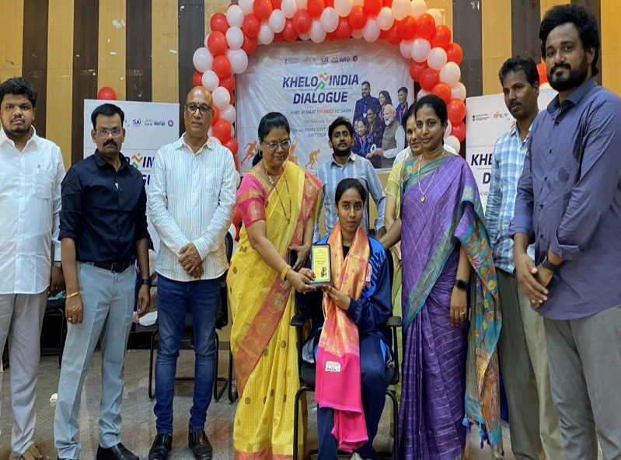
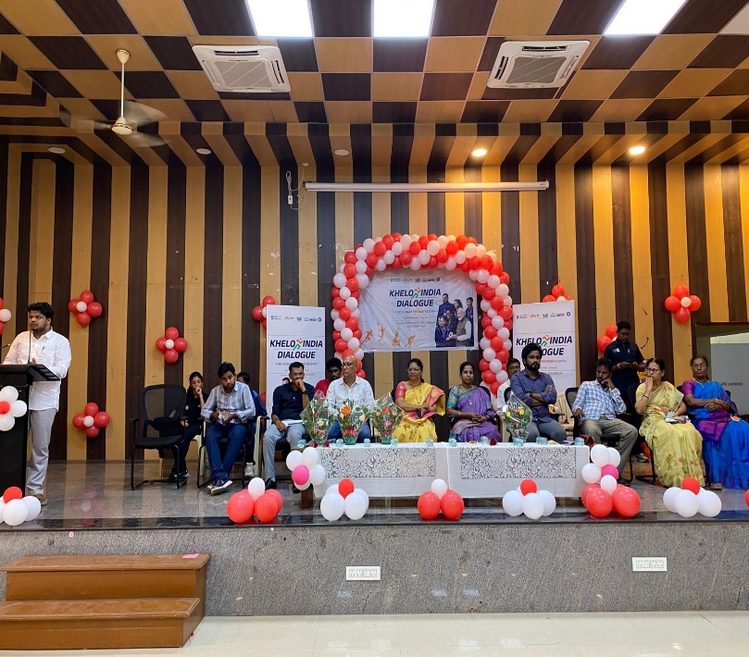
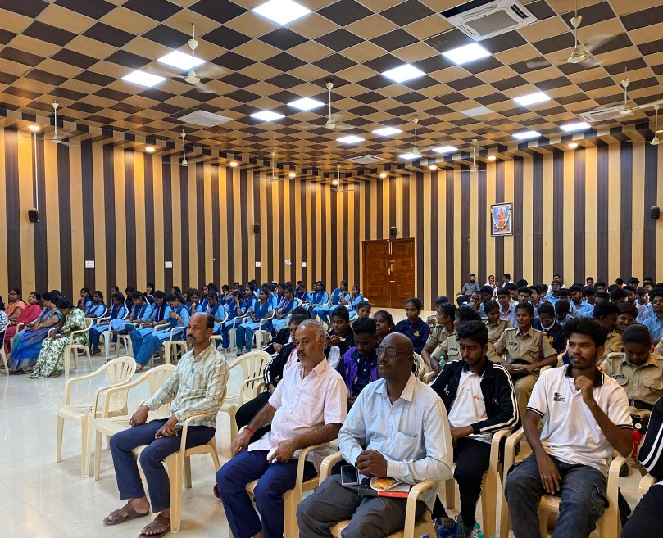

Field Visit

Department of Zoology conducted Field visit to Mahabalipuram and Arignar Anna Zoological Park, Vandalur, Chennai on 27/08/2026.Students observed Marine species, Aquatic ecosystem, Ecological roles of animal life in marine environment in Mahabalipuram ocean. Students observed different Animal species, Bird species, Aquarium and noted down unique animal behaviors, animal classification, feeding habits and learned Zoological park are established for wild life conservation.

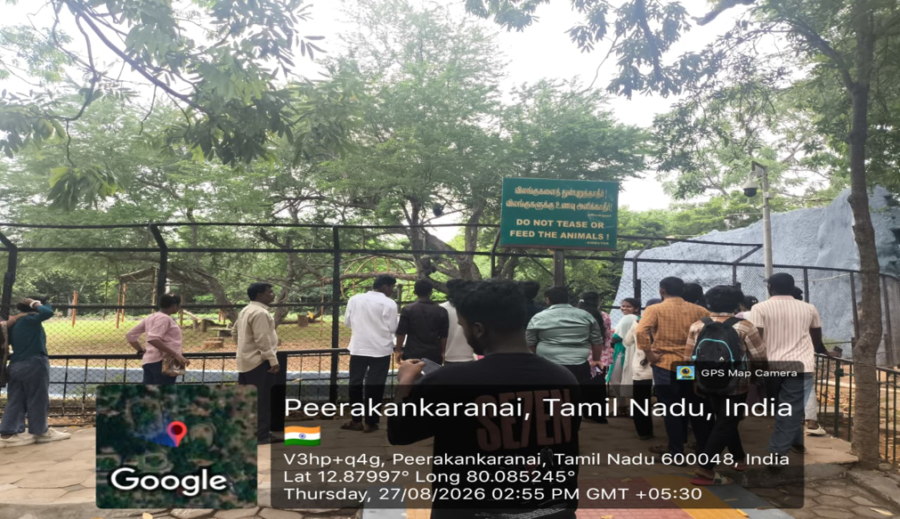
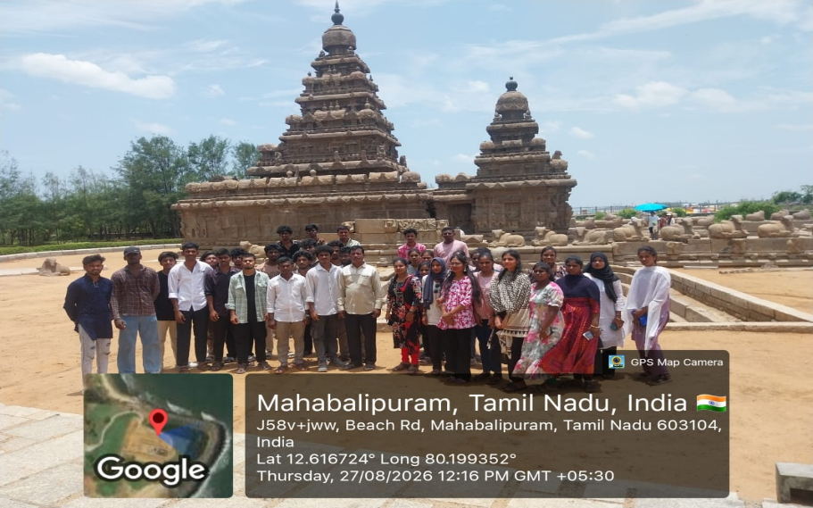
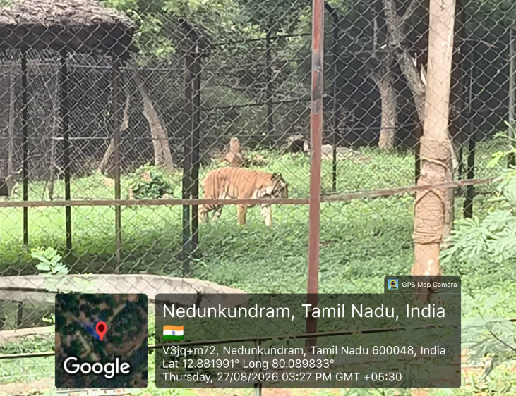

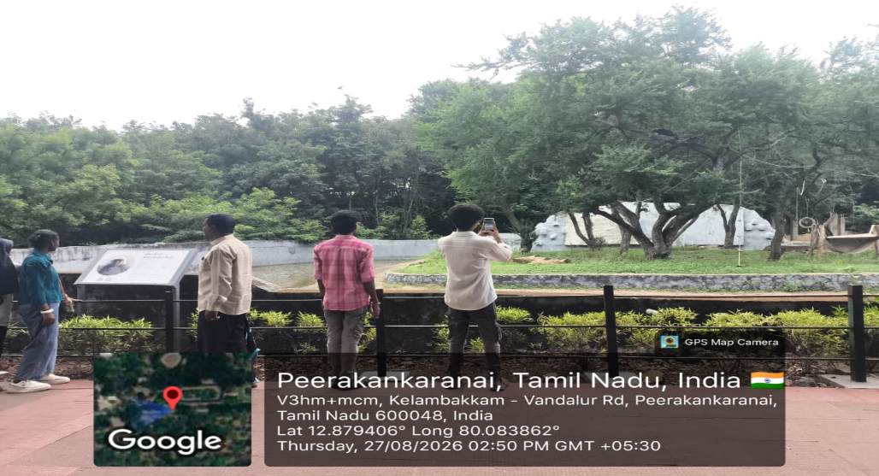

National Sports Day
The Sports Day programme was organized at PVKN Government Degree College (A), Chittoor, to recognize and appreciate the participation of the college students in the Amaravati Championship : 2026–27, a State Level Tournament held at Tirupati from 24th to 27th August 2026.
On this occasion, the significance of National Sports Day was also highlighted. Major Dhyan Chand, popularly known as the “Wizard of Hockey,” was one of India’s greatest hockey players. His exceptional skills, discipline and dedication brought great recognition to Indian hockey. National Sports Day is celebrated on 29th August every year to commemorate his birth anniversary. His life and achievements inspire students to develop discipline, teamwork, physical fitness, sportsmanship and dedication towards achieving their goals.
Sri. Ramesh, NCC Officer, explained the importance of Sports Day and emphasized that sports play an important role in the overall development of students. He encouraged students to actively participate in sports and maintain physical fitness.
Certificates will be given by P.Jeevan Jyoti, Principal to the participating students and congratulated them for representing the college at the State Level Tournament.
The Principal congratulated the students and encouraged them to continue their participation in sports and bring further laurels to the college.
A total of eight students from the college participated in different sporting events in various age categories. Their participation brought recognition to the college and encouraged other students to take an active interest in sports and physical activities.

1 | N. Naveen Kumar | 2nd B.A. | Under-23 | Athletics – 100 m

2 | S. Hussin Basha | 2nd B.Sc. | Under-23 | Athletics – 400 m

3 | S. Prathap | 3rd B.Com. | Under-23 | Kho-Kho

4 | N. Bhanu Prasad | 1st B.Sc. | Under-17 | Hockey

5 | K. Priyanka | 2nd B.Sc. | Under-23 | Kabaddi

6 | R. Bindhu | 2nd B.Com. | Under-23 | Kho-Kho

7 | G. Mochana | 2nd B.Sc. | Under-23 | Kho-Kho

8 | N. Meghanatha | — | Under-23 | Hockey

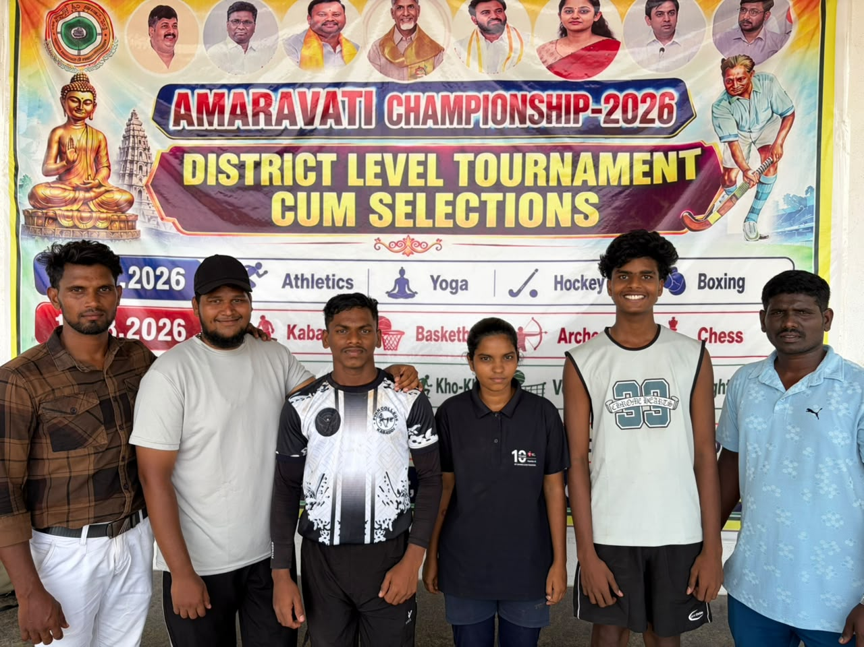

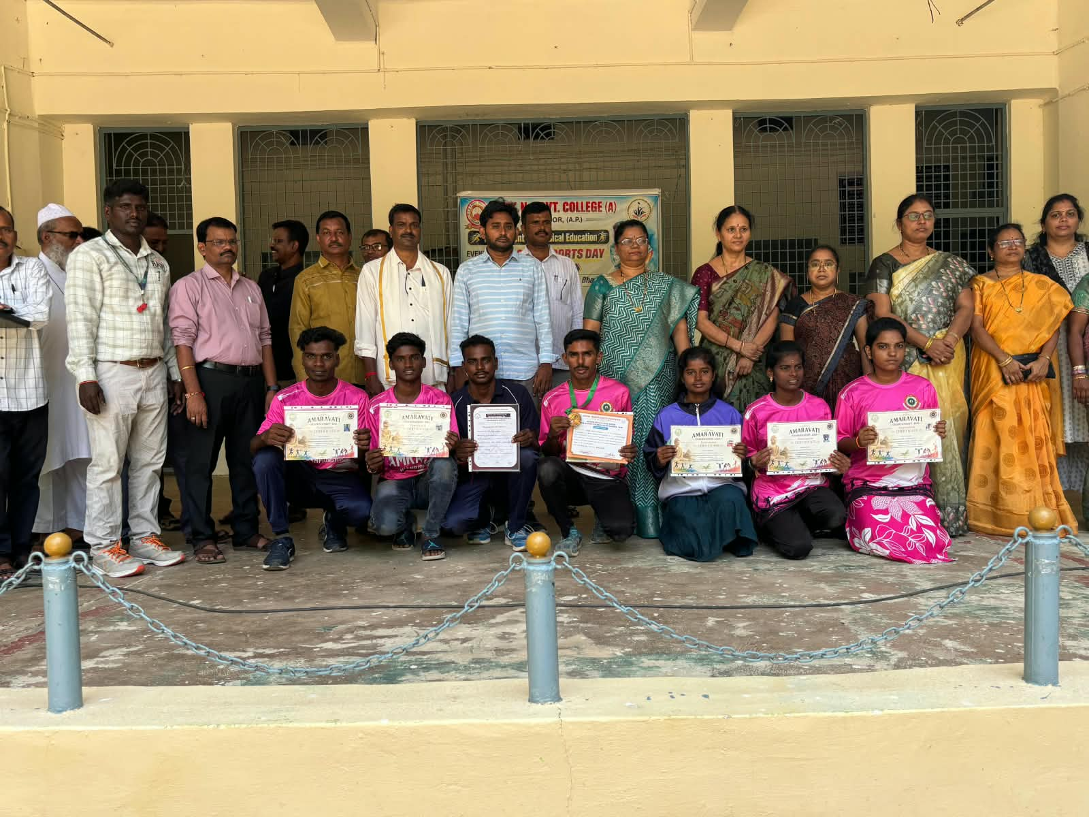

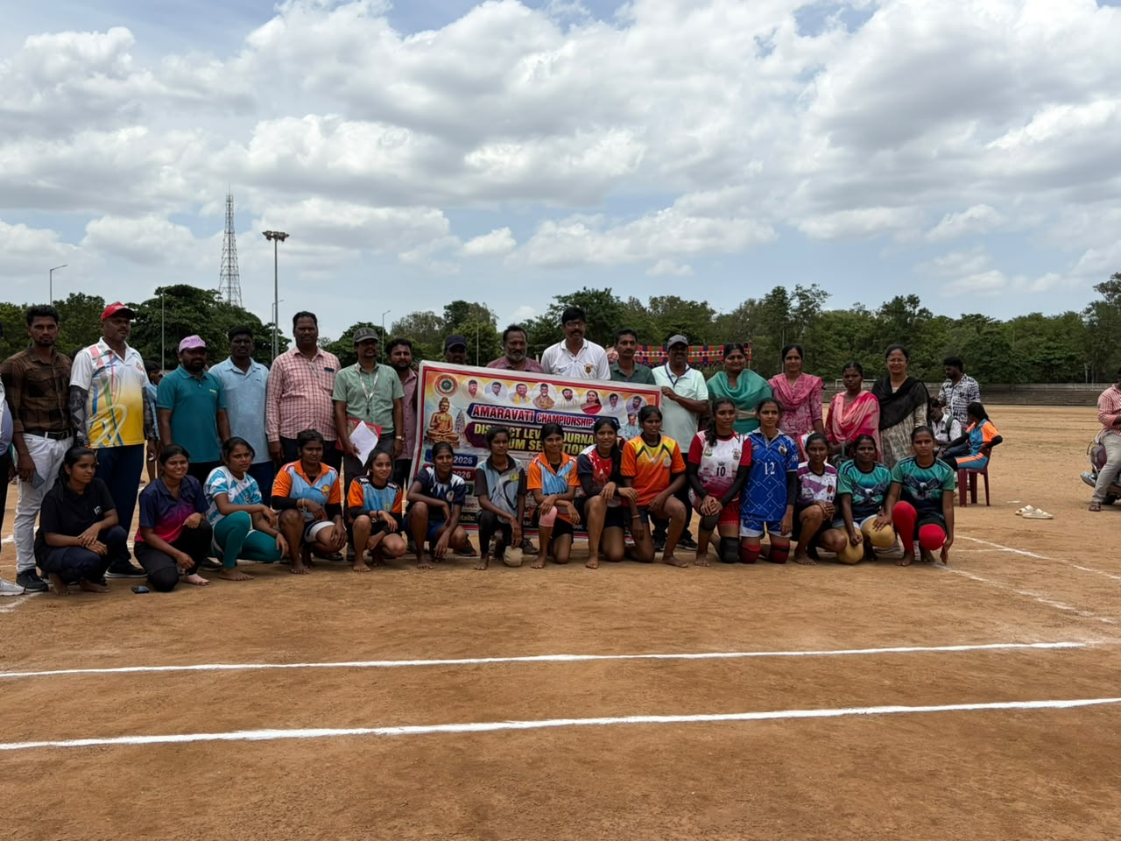

TELUGU BHASHA DINOTHSAVAM

Number of staff & students participated:25&152
Objectives:
Students learn about the importance of Telugu Language and Telugu Literature
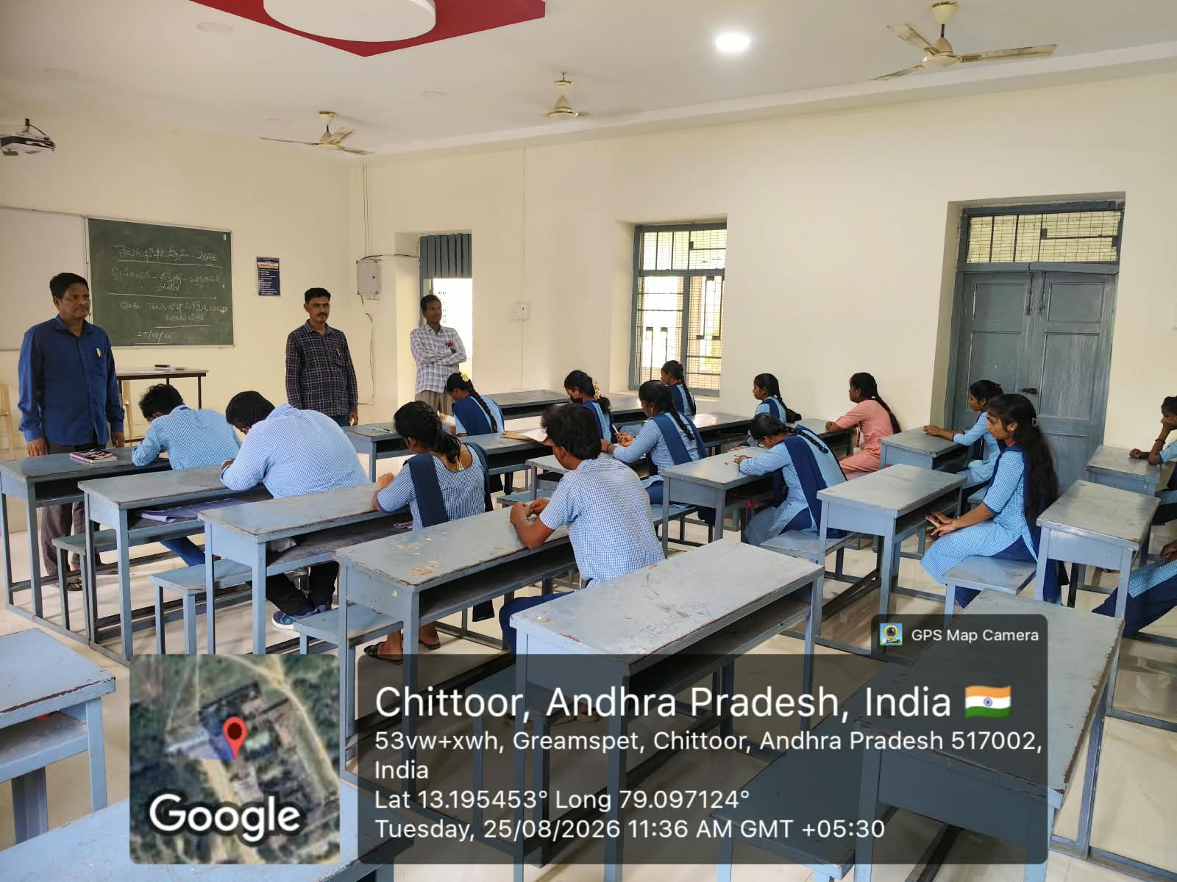
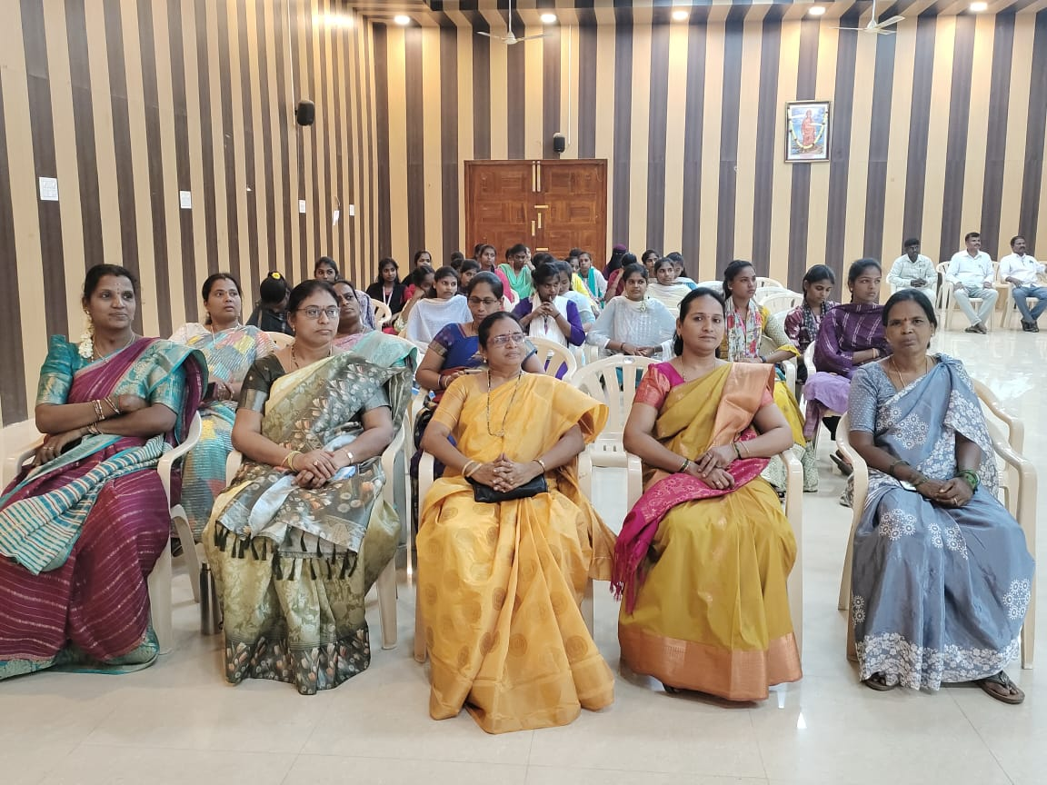
Telugu Bhasha Dinothsavam celebrations conducted by Deparment of Telugu on 29.08.2025 in College Auditorium . Dr. P. Jeevan Jyothi principal of this college preside over the function. Dr. C. Chennakesavulu, HOD, Department of Telugu and other Chief Guests Dr. G. Usharani, Lecturer in Telugu, Smt. NP Savithramma Govt, Degree College for Women(A)Chittoor spokes about the importance of Telugu Language and Telugu Literature . Other Lecturers Dr. A. Sasikala, Dr. P. Bhanuprakash and students also spokes about the importance of Telugu Language and Telugu Literature. Students are actively participated in this programme.
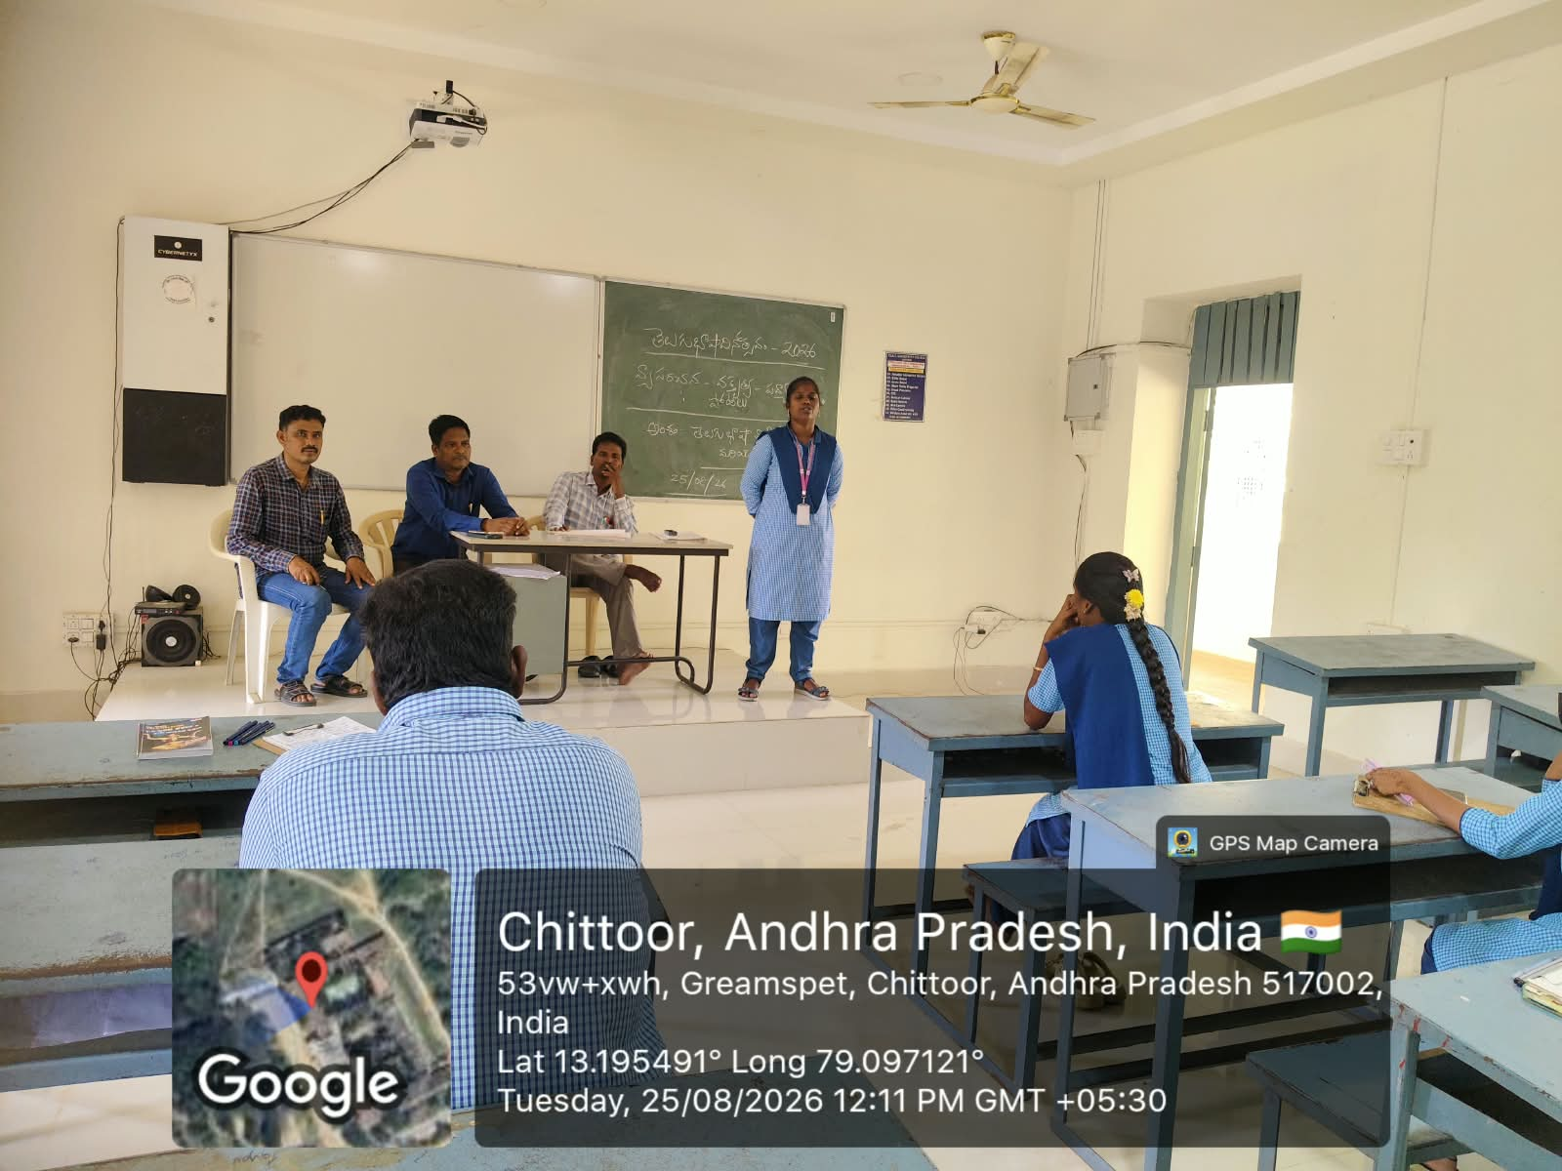
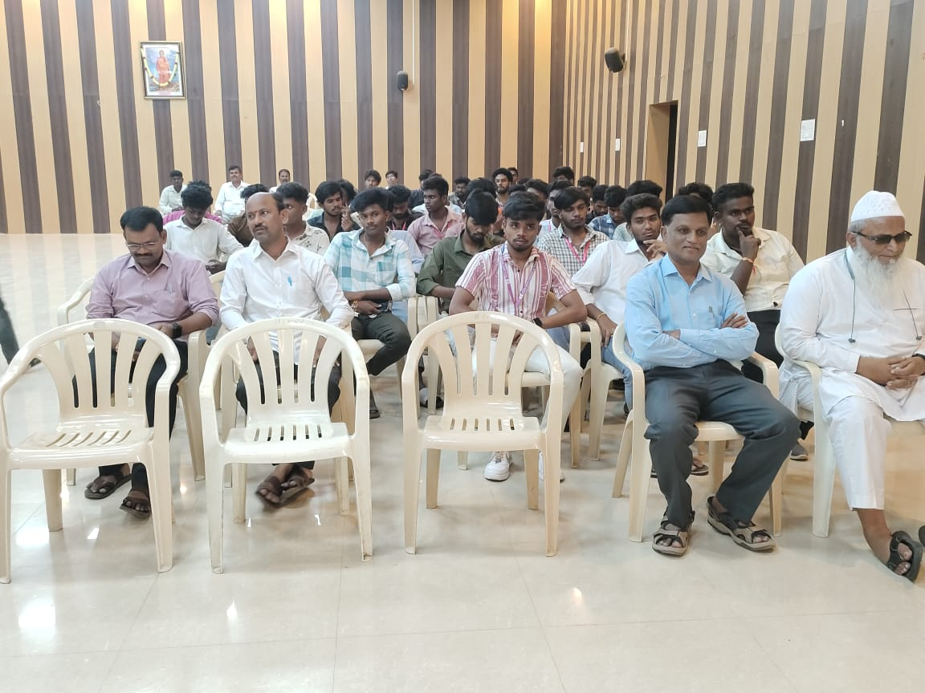

“TB MUKT BHARAT ABHIYAN”
An Awareness Programme on “TB Mukt Bharat Abhiyan” was organized at PVKN Government College (A), Chittoor, on 31-08-2026 with the objective of creating awareness among students about Tuberculosis (TB), its prevention, symptoms, diagnosis and treatment.
The programme was delivered by Dr. A. Jayasankar, Lecturer in Zoology, who explained the causes, symptoms and modes of transmission of tuberculosis. He highlighted the importance of early diagnosis, proper medical treatment and completing the prescribed course of medication. He also emphasized the role of a healthy lifestyle, proper nutrition, personal hygiene and community awareness in preventing the spread of TB.
The Principal, Dr. P. Jeevan Jyoti, along with the teaching and non-teaching staff and students, actively participated in the programme. The Principal appreciated the initiative and encouraged the students to spread awareness about TB prevention and contribute to the goal of a TB-free India.
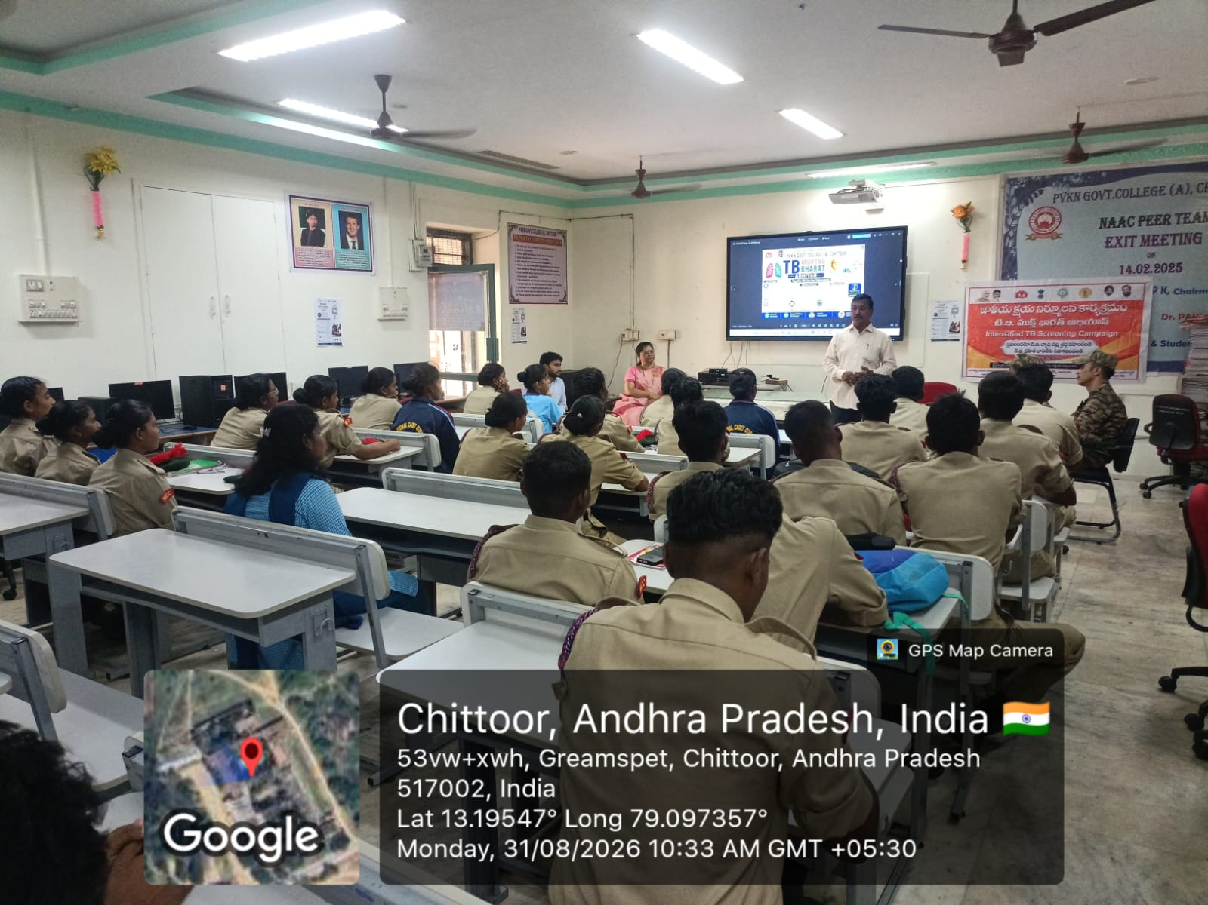
The programme was informative and beneficial to the students. It created awareness about the importance of timely identification and treatment of TB and encouraged students to become ambassadors of health awareness in their families and communities.
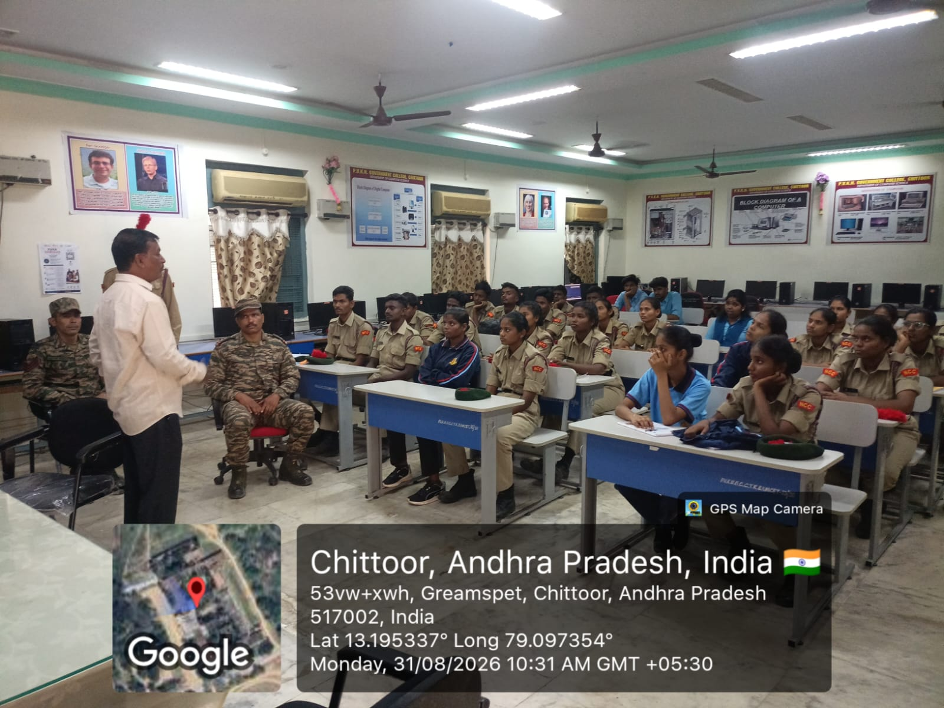

PAPER CLIPINGS:
